PROJECT REPORT ON

# STEEL INDUSTRY ENERGY CONSUMPTION PREDICTION



| J. Franklin | 1051-22-507-003 |
| --- | --- |
| N. Shivani | 1051-22-507-006 |
| G. Manisha | 1051-22-507-009 |
| D. Sri Laxmi | 1051-22-507-012 |
| K. Vaishnavi | 1051-22-507-015 |

Project submitted for the award of the degree of MASTER’S OF SCIENCE

BY

OSMANIA UNIVERSITY, HYDERABAD - 500007

# Aurora’s Degree & PG College

**Reaccredited by NAAC with ‘B’ grade**

# STEEL INDUSTRY ENERGY CONSUMPTION PREDICTION

This Project work dissertation is submitted to

Osmania University, as partial fulfillment for the completion of

M. Sc. IV semester of M. Sc. Statistics

## BY

| J. Franklin | 1051-22-507-003 |
| --- | --- |
| N. Shivani | 1051-22-507-006 |
| G. Manisha | 1051-22-507-009 |
| D. Sri Laxmi | 1051-22-507-012 |
| K. Vaishnavi | 1051-22-507-015 |



Under the supervision of

**Ms.Anusha**

# Department of Statistics, Aurora’s Degree, and PG College 2022 – 2024

1

# Department of Statistics, Aurora’s Degree, and PG College

**2022 – 2024**



# DECLARATION

I hereby declare that the project work presented in this dissertation, entitled

# “STEEL INDUSTRY ENERGY CONSUMPTION PREDICTION” has been

carried out by us under the supervision of **Ms.Anusha** in the department of Statistics,

Aurora’s Degree and PG College, Chikkadpally,Hyderabad – 500020. The work done is original and has not been submitted so far, in part or full, for any other degree or diploma to any University or institution.

| J. Franklin | 1051-22-507-003 |
| --- | --- |
| N. Shivani | 1051-22-507-006 |
| G. Manisha | 1051-22-507-009 |
| D. Sri Laxmi | 1051-22-507-012 |
| K. Vaishnavi | 1051-22-507-015 |

2



# Aurora’s Degree & PG College (Reaccredited by NAAC with ‘B’ grade)

**CERTIFICATE**

## DATE:26/08/2024

This is to certify that the research work presented in this thesis, entitled

# “STEEL INDUSTRY ENERGY CONSUMPTION PREDICTION” has been

carried out by

| J. Franklin | 1051-22-507-003 |
| --- | --- |
| N. Shivani | 1051-22-507-006 |
| G. Manisha | 1051-22-507-009 |
| D. Sri Laxmi | 1051-22-507-012 |
| K. Vaishnavi | 1051-22-507-015 |

registered M. Sc. Statistics students of this college. The work done is original and has not been submitted so far, in part or full, for any other degree or diploma to any University or institution.

## Signature of head with office seal Signature of the Supervisor

Internal Examiner Signature with date:

External Examiner Signature with date:

3



# ACKNOWLEDGMENT

I am thankful to my supervisor **Ms. Anusha,** Assistant Professor, Statistics

Department, Aurora’s Degree and PG College, Chikkadpally, Hyderabad – 500020, for her guidance.

I would like to express my sincere thanks to all the Faculty of Department of Statistics, Aurora’s Degree and PG College for their encouragement throughout the period of our course work.

I am grateful to have the support of **UNP** Team and express my sincere thanks to them for their guidance

| J. Franklin | 1051-22-507-003 |
| --- | --- |
| N. Shivani | 1051-22-507-006 |
| G. Manisha | 1051-22-507-009 |
| D. Sri Laxmi | 1051-22-507-012 |
| K. Vaishnavi | 1051-22-507-015 |

4



## INDEX

**CONTENT PAGE N0.**

1. **BACKGROUND1 7**
2. **STEEL INDUSTRY 8-11**
   1. INTRODUCTION TO STEEL INDUSTRY
   2. HISTORY
   3. INDUSTRY
   4. STEEL INDUSTRY IN SOUTH KOREA
   5. USES
   6. APPLICATIONS
3. **OBJECTIVE 12**
4. **ABSTRACT 12**
5. **LITERATURE REVIEW 13-14**
   1. LITERATURE REVIEW
   2. LITERATURE REVIEW
   3. LITERATURE REVIEW
6. **DATASET 8 15-16**
   1. SOURCE OF THE DATA
   2. SAMPLE DATA
   3. DATA DESCRIPTION
7. **DATASET LOADING 17-19**
8. **DATA CLEANING 20-26**
   1. NULL VALUES
   2. CHECKING FOR THE DATA TYPES
   3. ENCODING THE CATEGORICAL VARIABLES TO CONTINUOUS
   4. RENAMING THE COLUMN NAMES AND REMOVING THE COLUMN NAMES
   5. DATA ANALYSIS

5



1. **EXPLORATORY DATA ANALYSIS 27=38**
   1. HEATMAP OF CORRELATION MATRIX
   2. PIE CHARTS
   3. BAR PLOTS
   4. HISTOGRAM
   5. CATEGORICAL PLOT
   6. BOX PLOT
   7. PAIR PLOT
2. **SIGNIFICANCE TEST 39-43**
3. **MULTICOLLINEARITY CHECK 44-45**
4. **METHODOLOGY** 46-74
   1. MULTIPLE LINEAR REGRESSION
   2. DECISION TREE
   3. RANDOM FOREST
   4. K- NEAREST NEIGHBORS
   5. BAGGING REGRESSOR
   6. BOOSTING REGRESSOR
   7. SUPPORT VECTOR MACHINES
5. **COMPARISON OF ALGORITHMS 75**
6. **CONCLUSION 75**
7. **REFERENCES 76-77**

6



Background:

In 2021, it was estimated that around 7% of the global greenhouse gas emissions resulted from the steel industry. Reduction of these emissions are expected to come from a shift in the main production route using cokes, more recycling of steel and the application of carbon capture and storage or carbon capture and utilization technology.

The iron and steel industries are always energy-intensive, covering 10% of the full industry's energy consumption. Recently, with the rising energy resource shortage, the energy supply condition in the iron and steel industries has become highly challenging.

Due to the more energy consumption the carbon emission also increasing highly. To reduce these and to analyze how it works we have to predict the energy consumption of steel industries. So we took steel industry dataset of South Korea.

7



# Steel Industry

* 1. **Introduction to steel Industry:**

The steel industry has grown from ancient times, when a few men may have operated, periodically, a small furnace producing 10 kilograms, to the modern integrated iron- and steelworks, with annual steel production of about 1 million tons.

The steel industry is often considered an indicator of economic progress, because of the critical role played by steel in infrastructural and overall economic development**.**

Steel companies are increasingly focusing on sustainability, including reducing carbon emissions and implementing eco-friendly production methods.

Technological advancements: Automation and digitalization are transforming steel manufacturing, leading to improved efficiency and quality,

Due to the advancement of industrialization on a global scale and development of industry, the energy demand is elevated and is considered to be a major concern in national policy. Furthermore, economic growth and human development also add to the rapid growth of energy consumption. The Unregulated use of energy like over-consumption, poor infrastructure, and energy waste are the causes of such an outcome. Among the demanders of different sources of energy, Streimikiene forecasts a significant proportion of residential energy usage by 2030. As seen by Zuo, Energy consumptions in buildings cover 39 per cent of the total energy consumption of the United States.

8

# History

Steel was known in antiquity and was produced in [bloomeries](https://en.wikipedia.org/wiki/Bloomery) and [crucibles](https://en.wikipedia.org/wiki/Crucible).

The earliest known production of steel is seen in pieces of ironware excavated from an [archaeological site](https://en.wikipedia.org/wiki/Archaeological_site) in [Anatolia](https://en.wikipedia.org/wiki/Anatolia) ([Kaman-Kalehoyuk](https://en.wikipedia.org/wiki/Kaman-Kaleh%C3%B6y%C3%BCk)) which are nearly 4,000 years old, dating from 1800 BC.

High-carbon steel was produced in [Britain](https://en.wikipedia.org/wiki/British_Iron_Age) at [Broxmouth](https://en.wikipedia.org/wiki/Broxmouth) [Hillfort](https://en.wikipedia.org/wiki/Broxmouth) from 490–375 BC, and ultrahigh-carbon steel

was produced in the [Netherlands](https://en.wikipedia.org/wiki/Netherlands) from the 2nd-4th centuries AD.

The Roman author [Horace](https://en.wikipedia.org/wiki/Horace) identifies steel weapons such as the [*falcata*](https://en.wikipedia.org/wiki/Falcata) in the [Iberian Peninsula,](https://en.wikipedia.org/wiki/Iberian_Peninsula) while [Noric steel](https://en.wikipedia.org/wiki/Noric_steel) was used by the [Roman military](https://en.wikipedia.org/wiki/Military_of_ancient_Rome).

There is evidence that [carbon steel](https://en.wikipedia.org/wiki/Carbon_steel) was made in Western [Tanzania](https://en.wikipedia.org/wiki/Tanzania) by the ancestors of the [Haya](https://en.wikipedia.org/wiki/Haya_people) [people](https://en.wikipedia.org/wiki/Haya_people) as early as 2,000 years ago by a complex process of "pre-heating" allowing temperatures inside a furnace to reach 1300 to 1400 °C.

# Industry

The steel industry is often considered an indicator of economic progress, because of the critical role played by steel in infrastructural and overall [economic development.](https://en.wikipedia.org/wiki/Economic_development) In 1980, there were more than 500,000 U.S. steelworkers. By 2000, the number of steelworkers had fallen to 224,000.

The [economic boom](https://en.wikipedia.org/wiki/Boom_and_bust) in China and India caused a massive increase in the demand for steel. Between 2000 and 2005, world steel demand increased by 6%. Since 2000, several Indian and Chinese steel firms have expanded to meet demand, such as [Tata Steel](https://en.wikipedia.org/wiki/Tata_Steel) (which bought [Corus](https://en.wikipedia.org/wiki/Corus_Group) [Group](https://en.wikipedia.org/wiki/Corus_Group) in 2007), [Baosteel Group](https://en.wikipedia.org/wiki/Baosteel_Group) and [Shagang Group](https://en.wikipedia.org/wiki/Shagang_Group). As of 2017, though, [ArcelorMittal](https://en.wikipedia.org/wiki/ArcelorMittal) is the world's [largest steel producer.](https://en.wikipedia.org/wiki/List_of_steel_producers)

In 2021, it was estimated that around 7% of the global greenhouse gas emissions resulted from the steel industry. Reduction of these emissions are expected to come from a shift in the main production route using cokes, more recycling of steel and the application of carbon capture and storage or carbon capture and utilization technology.

9

# Steel Industry in South Korea:

In South Korea, production industry has begun to evolve at an elevated pace since the 1990s and has become the primary pushing power with the fast economic development continuing in South Korea. In the 1990s, primary power usage grew at an annualized pace of 7.5%, which in the same era was greater than the annualized financial development level of 6.5%. This is due to strong development in energy-intensive sectors, including petrochemical sectors.

The strong increase in industrial electricity consumption helped to boost the reduction of energy conversion, which further subverted energy intensity. The increase in energy production after 2009 significantly buffered the country against the global financial crisis but adversely affected the overall energy efficiency of the country. The energy consumption of the industries is impacted by several unstable variables, like industrial structure, level of technology, cost of energy, financial scale and national policy.

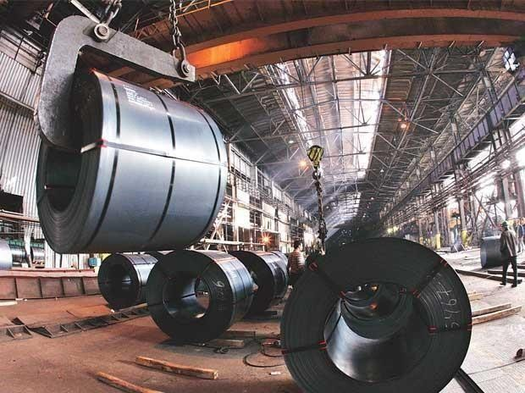

Research and industrial practice draw primary concern in forecasts related to energy resource and planning issues, which resulted due to the increasing issues of oil and coal shortages. Making fair use of by-product gasses in the steel industry demands scheduling operators to be aware of the quantity of real-time generation, usage and storage. The accurate prediction of these units of energy flow provides a useful guide for their planning and distribution.

10



The iron and steel industries are always energy-intensive, covering 10% of the full industry's energy consumption. Recently, with the rising energy resource shortage, the energy supply condition in the iron and steel industries has become highly challenging.

Establishing an energy-saving plan is a common task that can be achieved in areas such as technological development, refurbishing of equipment and improving management. When oil prices increase, the cost of consuming energy is 10-20 times higher than that of the total production of the iron and steel industries. High energy consumption results in higher prices for the iron and steel products which lead to increased pollution and emissions.

To this end, several steps, such as improving the production framework and accelerating the improvement and advancement of power saving and discharge reducing techniques, are required to ensure efficient energy supply in the manufacturing industry in South Korea**.**

# Uses:

Iron and steel are used widely in the construction of roads, railways, other infrastructure, appliances, and buildings. Most large modern structures, such as [stadiums](https://en.wikipedia.org/wiki/Stadium#The_modern_stadium) and skyscrapers, bridges, and airports, are supported by a steel skeleton. Even those with a concrete structure employ steel for reinforcing. It sees widespread use in [major appliances](https://en.wikipedia.org/wiki/Major_appliances) and [cars.](https://en.wikipedia.org/wiki/Automobile) Despite the growth in usage of [aluminum](https://en.wikipedia.org/wiki/Aluminium), steel is still the main material for car bodies. Steel is used in a variety of other construction materials, such as bolts, [nails](https://en.wikipedia.org/wiki/Nail_(engineering)) and [screws,](https://en.wikipedia.org/wiki/Screw) and other household products and cooking utensils.

# Applications of steel:

common applications include

* [shipbuilding](https://en.wikipedia.org/wiki/Shipbuilding)
* [pipelines](https://en.wikipedia.org/wiki/Pipeline_transport)
* [mining](https://en.wikipedia.org/wiki/Mining)
* [offshore construction](https://en.wikipedia.org/wiki/Offshore_construction)
* [aerospace](https://en.wikipedia.org/wiki/Aerospace)
* [white goods](https://en.wikipedia.org/wiki/White_goods)

11



# Title: STEEL INDUSTRY ENERGY CONSUMPTION PREDICTION

1. **Objective:**

**To find the suitable machine learning model to predict the energy consumption in steel industry for implementing eco-friendly production method.**

# Abstract:

Predictions of Energy Consumption for Industries gain an important place in energy management and control system, as there are dynamic and seasonal changes in the demand and supply of energy. This paper presents and discusses the predictive models for energy consumption of the steel industry

This article presents a machine learning model for predicting energy consumption in the steel industry, which aids in energy management, cost reduction, environmental regulation compliance, informed decision making for future energy investments, and contributes to sustainability. The dataset used for the prediction model comprises 11 attributes and 35,040 instances. The project focuses on the development of a model that accurately predicts energy consumption in the steel industry, leading to more sustainable and efficient practices.

Data used includes lagging and leading current reactive power, lagging and leading current power factor, carbon dioxide (tCO2) emission and load type. The study explores various machine learning algorithms like linear regression, decision tree, random forest, K-nearest neighbors, support vector machines, bagging and boosting to predict power consumption.

12

1. **Literature Review**

# Literature review- 1

**K. Karthick, R. Dharmaprakash, S. Sathya:**

The CatBoost prediction algorithm was employed for energy consumption prediction, and hyperparameter optimization was performed using GridSearchCV with 5-fold cross-validation. The developed model has undergone a comparative analysis based on both Root Mean Squared Error (RMSE) and Mean Absolute Percentage Error (MAPE) metrics, demonstrating its promise for accurate energy consumption prediction on both the training and test sets. The proposed model accurately predicts energy consumption for different load types, achieving impressive results on both the training set (RMSE=0.382, R 2=0.999, MAPE=1.139) and the test set (RMSE=1.073, R2=0.998, MAPE=1.142). These findings highlight the potential of CatBoost as a valuable tool for energy management and conservation, enabling organizations to make informed decisions, optimize resource allocation, and promote sustainability.

# Literature review -2 Sathishkumar V E:

Predictions of Energy Consumption for Industries gain an important place in energy management and control system, as there are dynamic and seasonal changes in the demand and supply of energy. This paper presents and discusses the predictive models for energy consumption of the steel industry. Data used includes lagging and leading current reactive power, lagging and leading current power factor, carbon dioxide (tCO2) emission and load type.

* + - In the test set, four statistical models are trained and evaluated: Linear regression (LR)

Support Vector Machine with radial kernel (SVM RBF) Gradient Boosting Machine (GBM)

Random Forest (RF)

* + - Root Mean Squared Error (RMSE), Mean Absolute Error (MAE) and Mean Absolute Percentage Error (MAPE) are used to measure the prediction efficiency of regression designs. When using all the predictors, the best model RF can provide RMSE value 7.33in the test set.

13



# 4.2 Literature review- 3 Myeongbae Lee & [YubinKim](http://ktsde.kips.or.kr/digital-library/category-search?author=Yubin%20Kim):

This paper explores the potential for predicting energy consumption by data mining approaches. This study leads to the conclusion that RF is best in predicting the energy and GBM performance also equal to RF. So, RF and GBM are more suitable for predicting steel industry energy consumption prediction. A accurate long-term forecast of energy usage is one among the most critical problems for energy management and optimization in the steel industry. In the exploratory analysis the data analysis reveals thought-provoking results. This work aims to establish the best performing prediction algorithm to predict the hourly consumption of energy in the steel industry. The findings indicate that the RF model improves RMSE, MAE, and MAPE of predictions in consideration to other regression models considered in this research.

14



# Dataset

* 1. **Source of the data:** The steel industry data is secondary dataset. We collected this dataset of steel industry data.csv from UC Irvine.

# Sample data:

This is the sample dataset of size 15

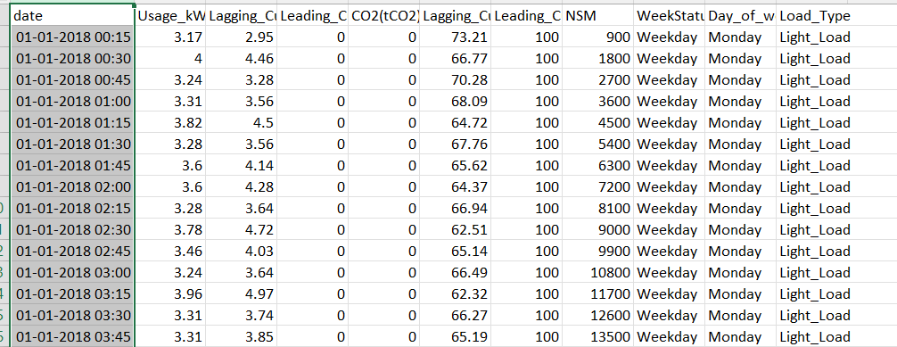

15



# Data Description:

This dataset contains current usage, carbon-di-oxide emission and load types. It contains 11 variables namely

## Usage_kVarh

* **Lagging_Current_Reactive.Power_kVarh**

## Leading_Current_Reactive.Power_kVarh

* **Lagging_Current_Power_Factor_kVarh**

## Leading_Current_Power_Factor_kVarh

* **CO2 (tCO2)**

## NSM

* **WeekStatus**

## LoadType

* **Day_of_week**

# Variables description:

Lagging current reactive power occurs when the current waveform in an AC circuit lags behind the voltage waveform in phase.

Leading reactive power happens when the current waveform in an electrical system leads the voltage waveform in phase

A lagging power factor occurs in a circuit when the current lags behind the voltage A leading current power factor occurs when the current in a circuit leads the voltage.

NSM-Number of Seconds from midnight Continuous S

16



# Dataset loading Importing the libraries

17



# Loading the Data Set:

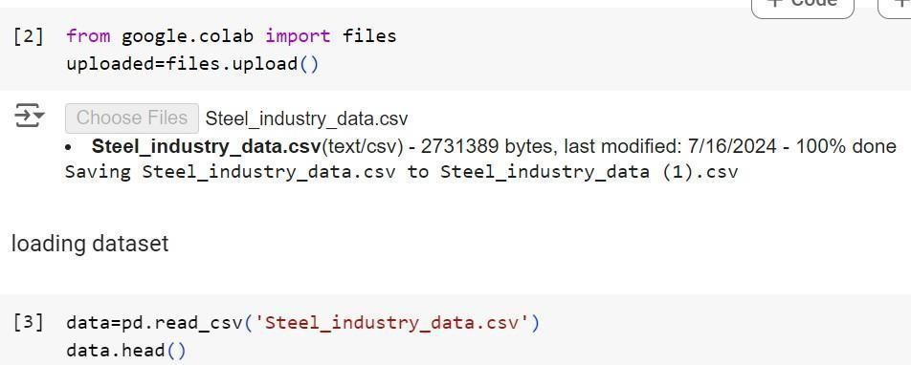

18



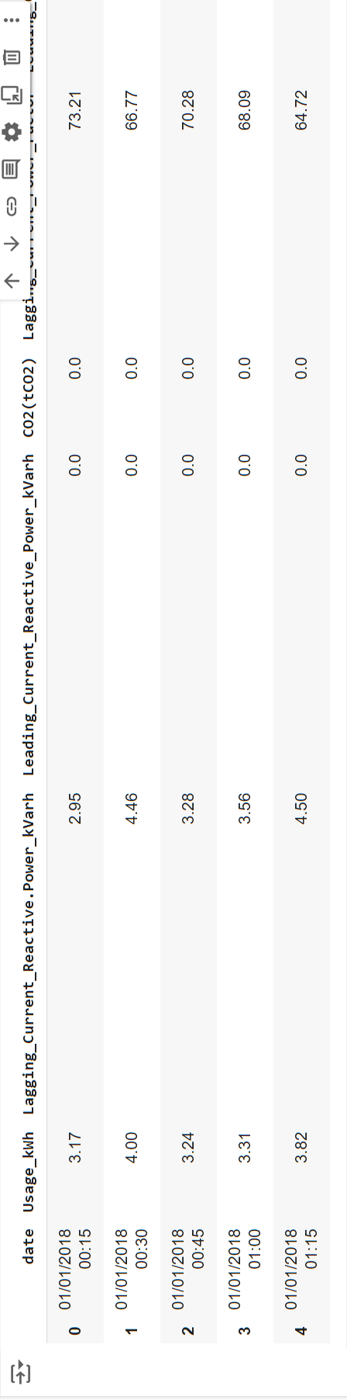

19



# Data cleaning

## Null Values:

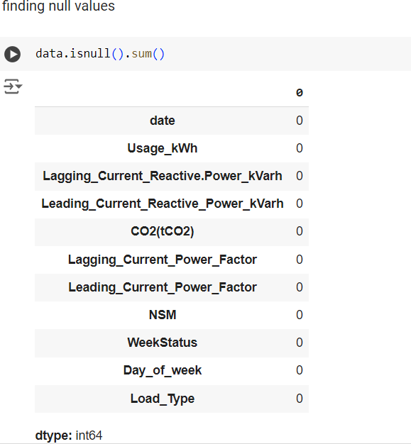

20



* 1. **Checking for the data type:**

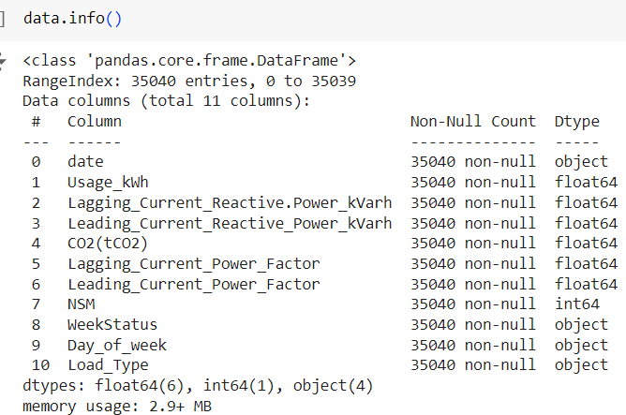

21



# Converting the categorical variables into continuous variables:

## After removing date column, we enlabled the factors in the variable WeekStatus

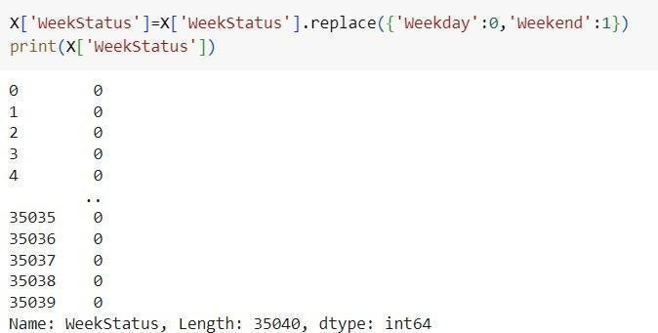

22

## Dummy Variable encoding:

For dummy variable encoding we divided the dataset into 2 different datasets one with categorical after enlabling the variable WeekStatus and second data set with continuous variables.

## Data-1

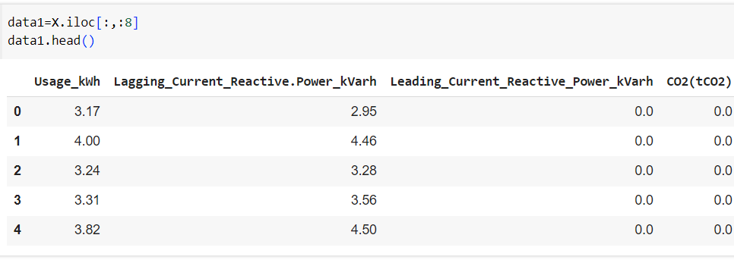

**Data-2**

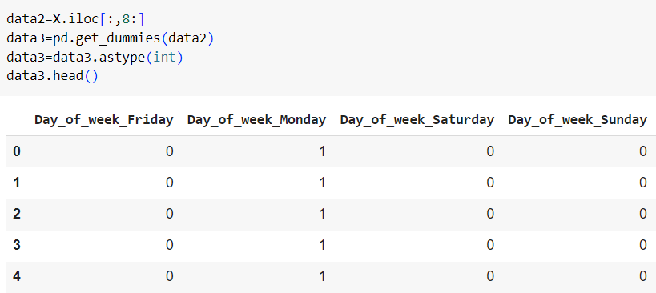

23



## Renaming the column names and removing day of week columns

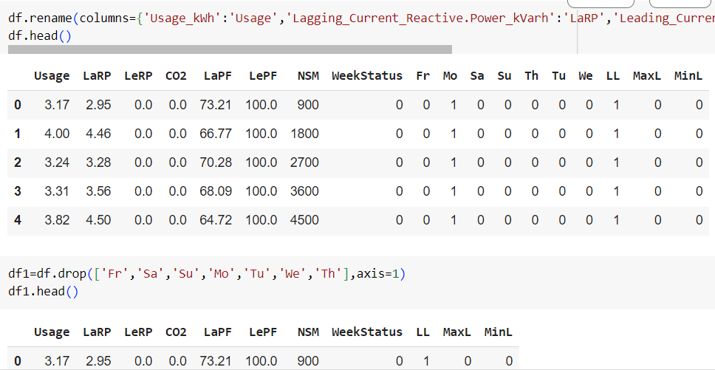

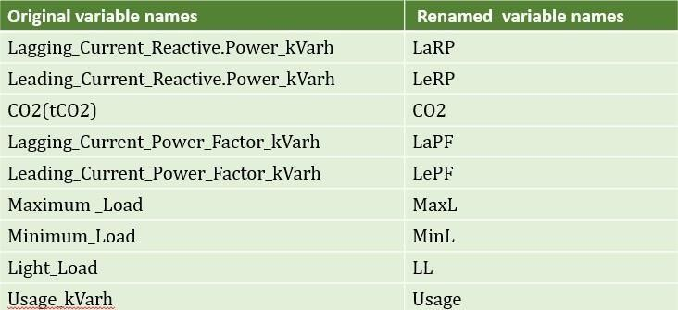

24



# Data Analysis

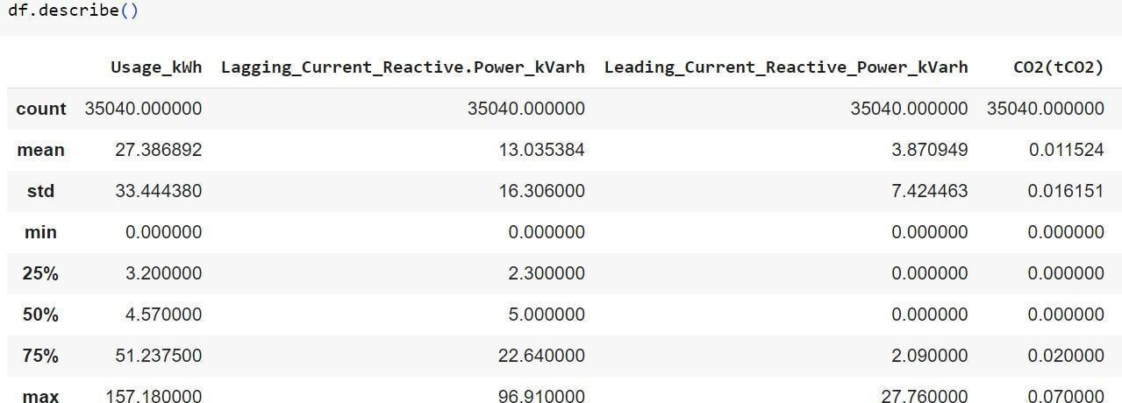

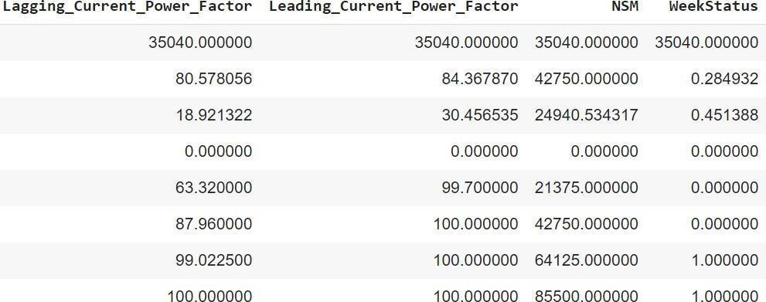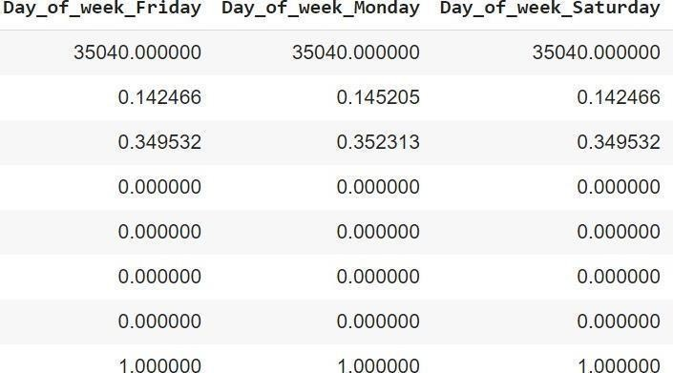

25



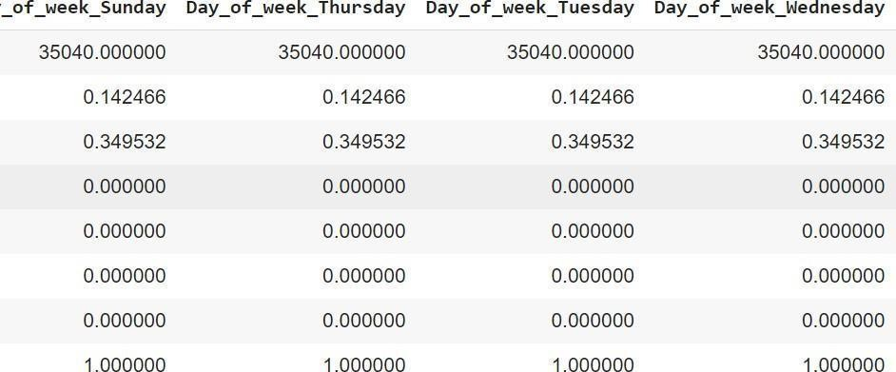

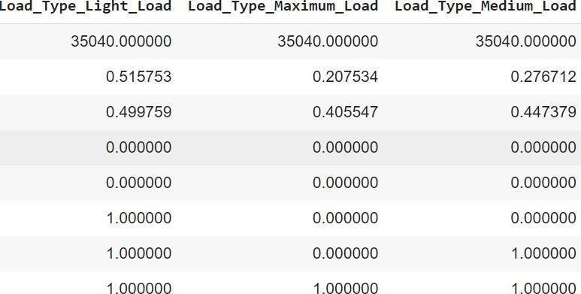

26



# Exploratory Data Analysis:

* 1. **Heatmap of correlation matrix:**

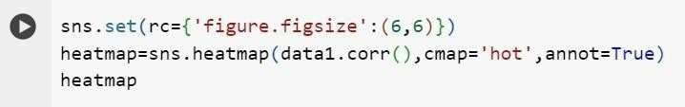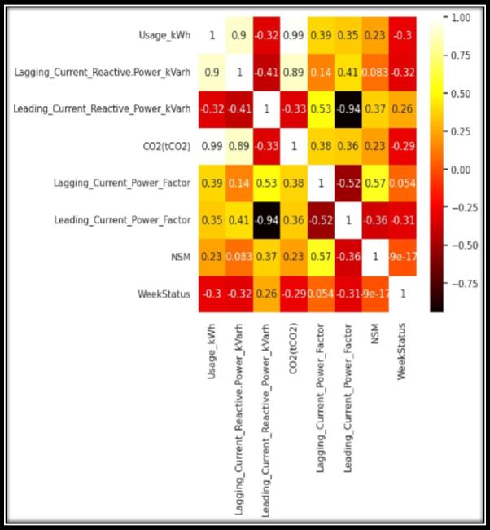

27



Here, we can observe CO2 and lagging current reactive power are most positively correlated with respect to usage and leading current power factor and reactive power are most negatively correlated.

The values nearer to the 1 and -1 are said to be strongly correlated and values nearest to 0 are weakly correlated.

# Pie Charts:

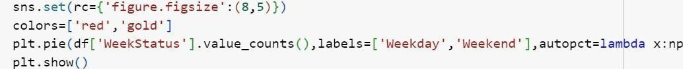

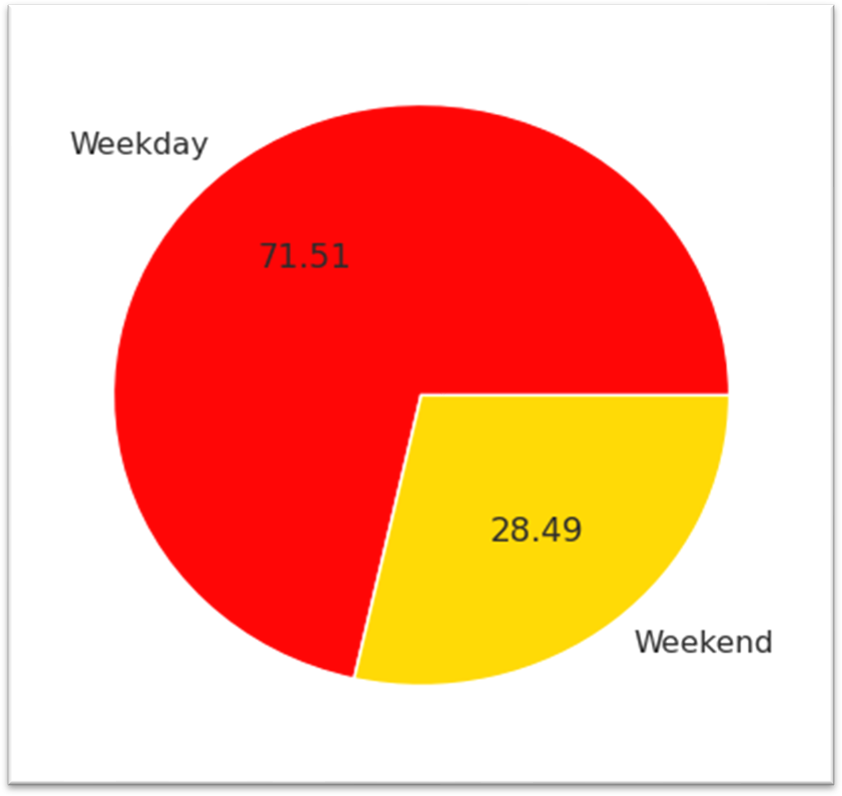

This plot explains about the percentage of weekdays and weekends in the dataset. 71.51% of data consists of weekdays and 28.49% of data consists of weekends.

28



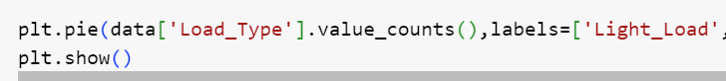

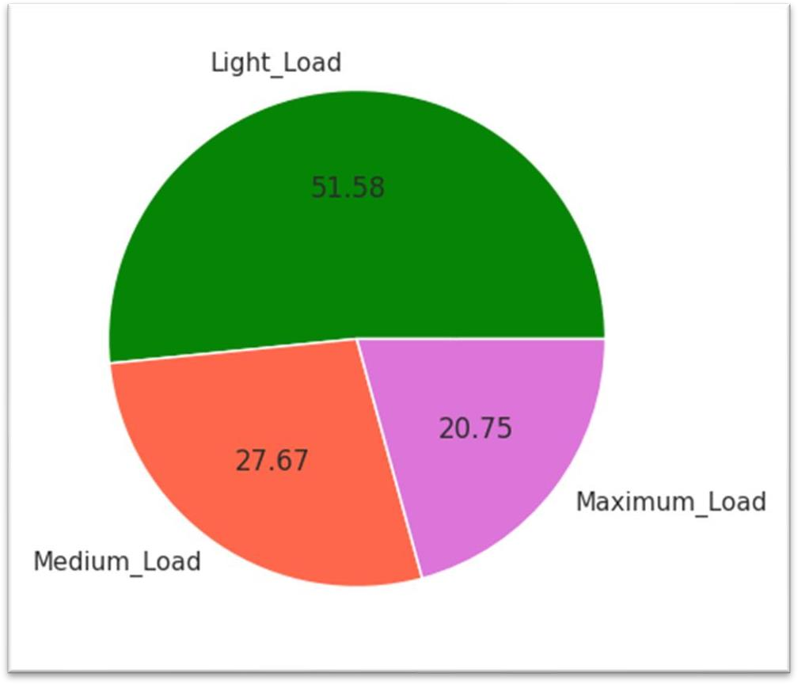

This plot explains about the percentage of load types.

* 51.58% of data consists of light load
* 27.67% of data consists of medium load
* 20.75% of data consists of maximum load

29



# Bar Plots:

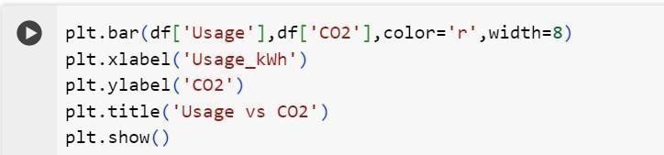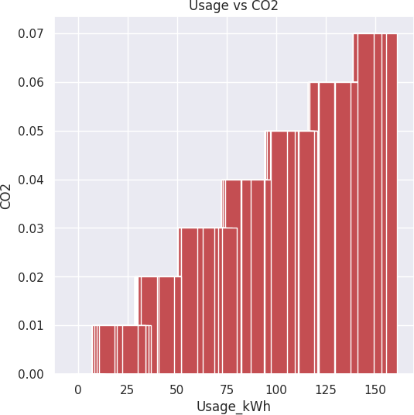

This plot explains, as usage increases CO2 emission also increases.

30



**Lagging current reactive power, leading current reactive power vs Usage**

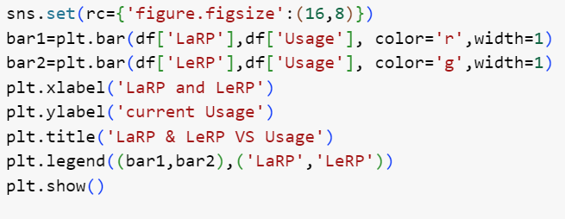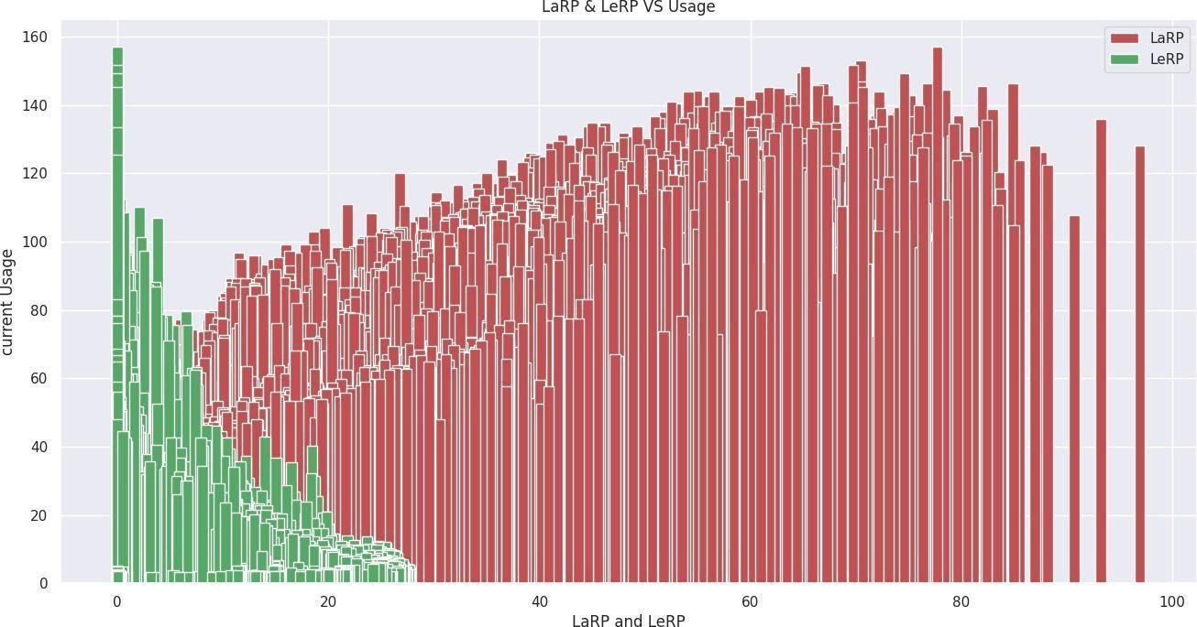

This plot explains as usage increases LeRP decreases and LaRP increases

31



# Histogram

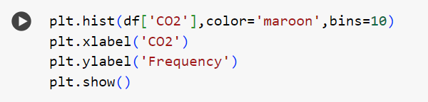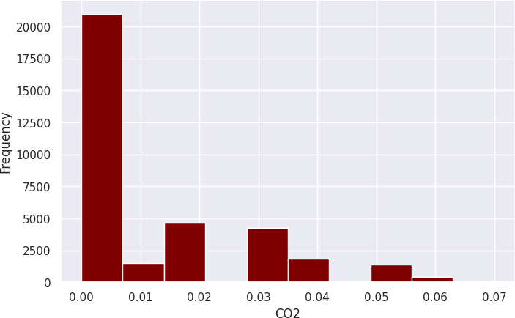

This plot gives the count of CO2 emission rate.

32



## Histogram for load type

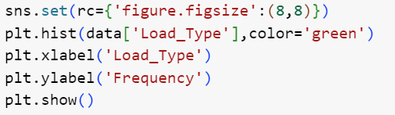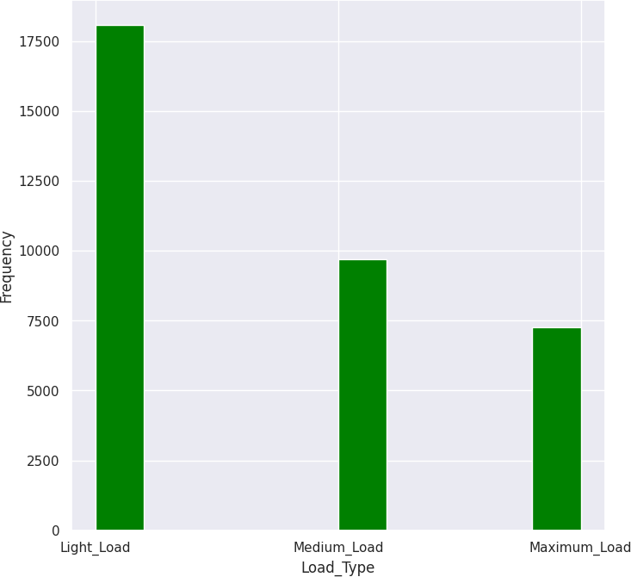

33



# Categorical plot

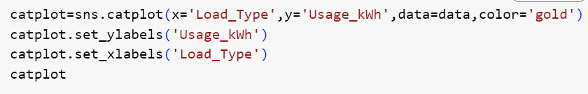

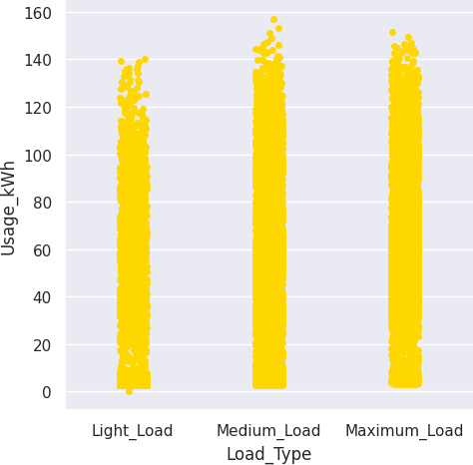

This plot gives the usage of the different load types.

34

**Categorical plot for Day of week**

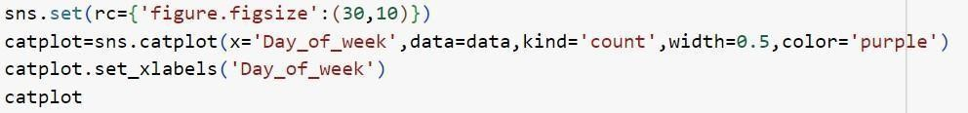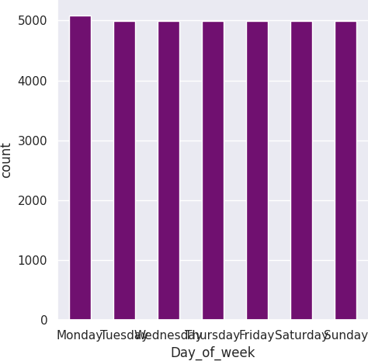

# Here, we observe that Monday was repeated more number of times than remaining days.

35

# Boxplot

**Boxplot for lagging current power factor**



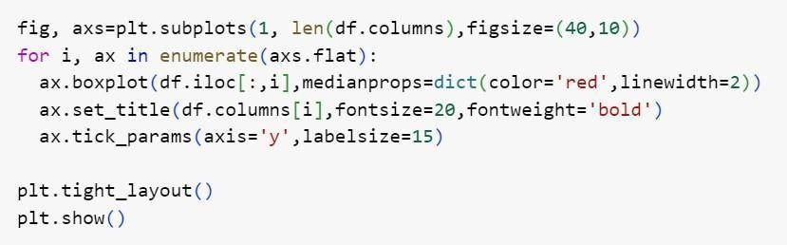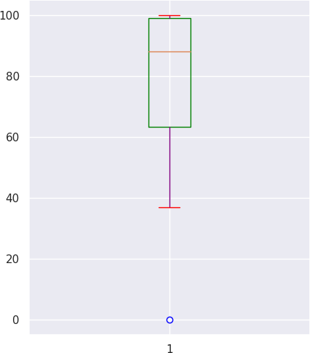

36

## Box plot for all continuous variables

A box plot (aka box and whisker plot) uses boxes and lines to depict the distributions of one or

\more groups of numeric data. Box limits indicate the range of the central 50% of the data, with a central line marking the median value. Lines extend from each box to capture the range of the remaining data, with dots placed past the line edges to indicate outliers.

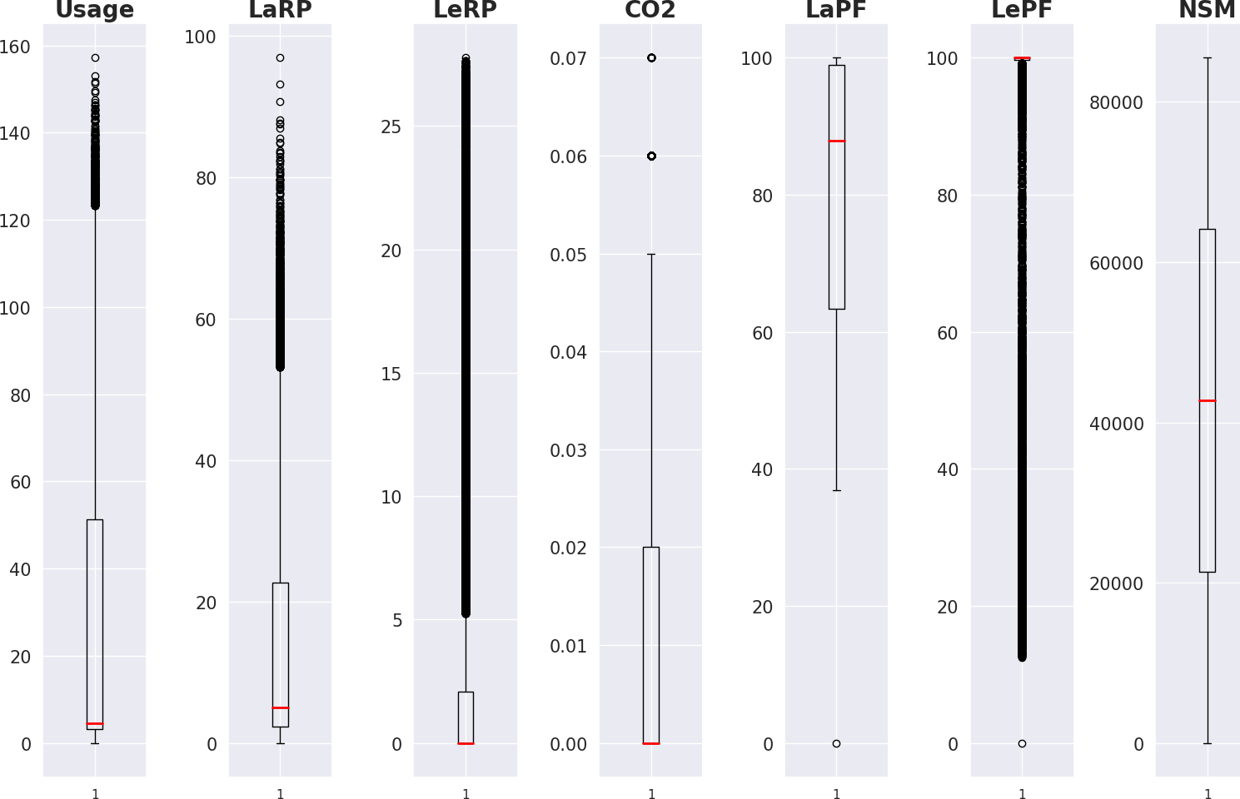

Here, we can observe LePF contains a greater number of outliers.

Next greater number of outliers contains in leading current reactive power.

37



# Pair Plot:

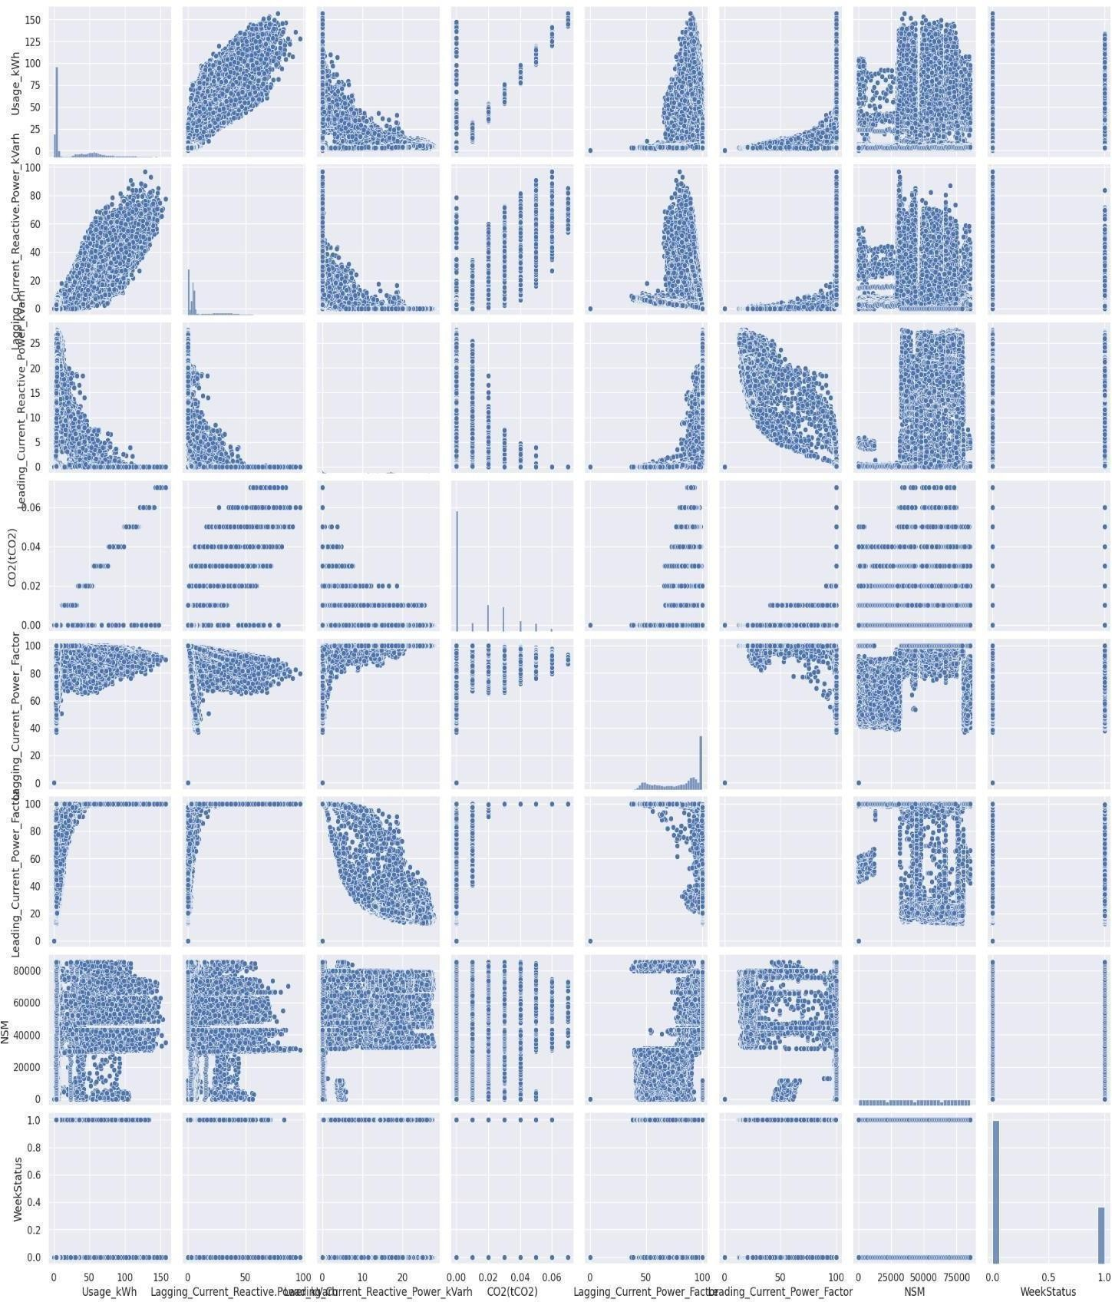

38



# Significance Test:

A significance test is a method used to measure the strength of inductive evidence and determine the level of significance of a hypothesis. It assigns high significance to evidence that makes the hypothesis highly unlikely.

Statistical significance plays a pivotal role in statistical hypothesis testing. It is used to determine whether the [null hypothesis](https://en.wikipedia.org/wiki/Null_hypothesis) should be rejected or retained. The null hypothesis is the hypothesis that no effect exists in the phenomenon being studied. For the null hypothesis to be rejected, an observed result has to be statistically significant, i.e. the observed *p*-value is less than the

pre-specified significance level.

To determine whether a result is statistically significant, a researcher calculates a *p*-value, which is the probability of observing an effect of the same magnitude or more extreme given that the null hypothesis is true. The null hypothesis is rejected if the *p*-value is less than (or equal to)

a predetermined level, is also called the *significance level*, and is the probability of rejecting the null hypothesis given that it is true (a [type I error](https://en.wikipedia.org/wiki/Type_I_error#Type_I_error)). It is usually set at or below 5%

## Fitting ordinary least squares method:

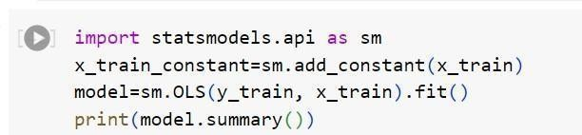

**The variables which have the P-value greater than 0.05 are said to be insignificant variable and less than 0.05 are considered to be significant variable.**

39



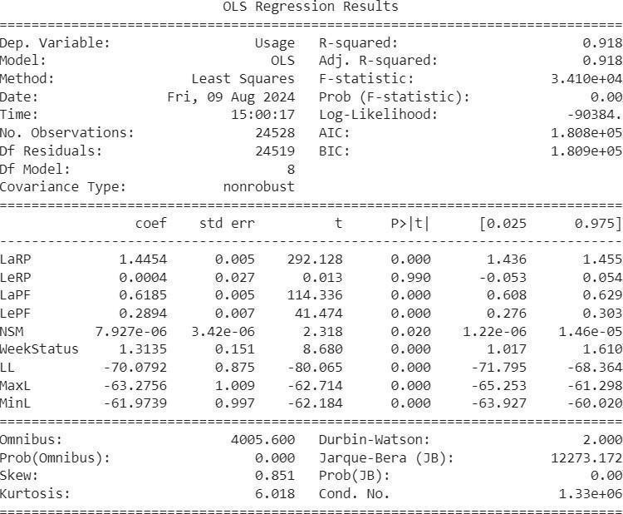

Here we can observe **Leading current reactive power (LeRP)** have greatest **P-value which is greater than 0.05**. We call it as **insignificant variable,** so we have removed that variable and again fitted the OLS model after **removing LeRP**.

40



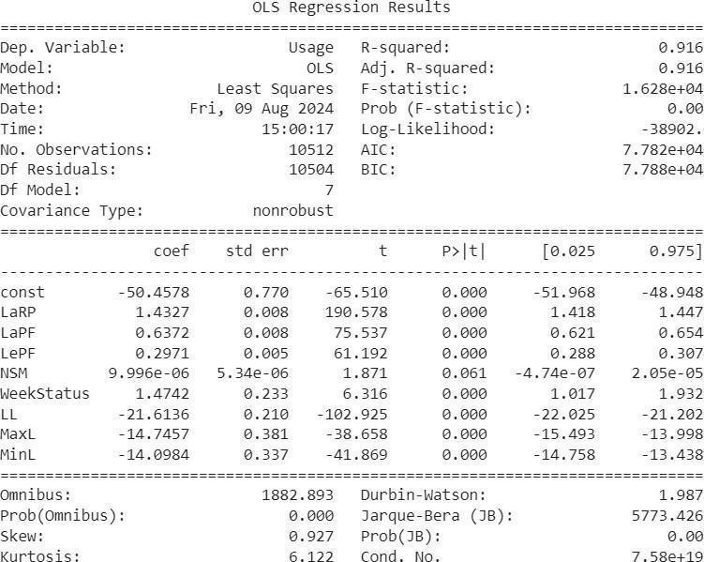

Here, we can observe the variable NSM has greater P-value we removed that variable and performed the significance test and got all the variables with significant values.

41



## Assigning the coefficients with respect to their variables: Model -1 (with all the features except CO2):

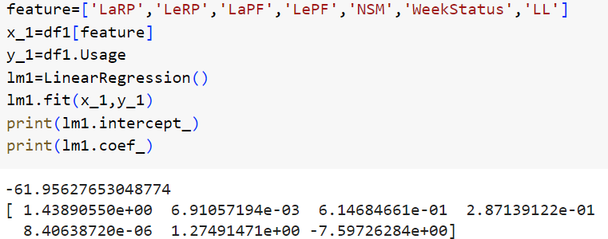

**Multiple linear model:**

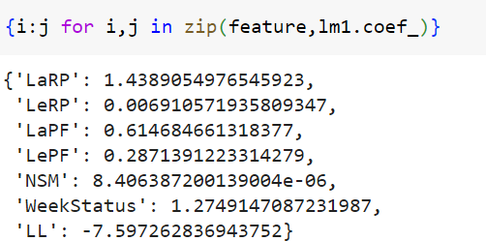

42



## Model – 2 (without multicollinear variables):

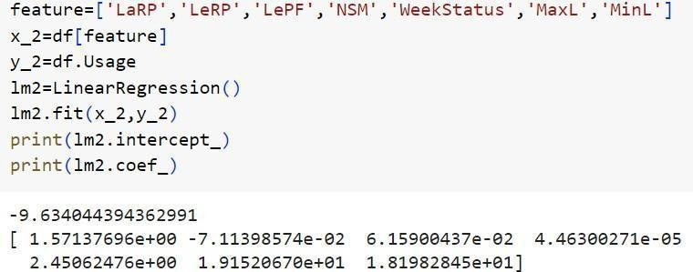

**Multiple linear model:**

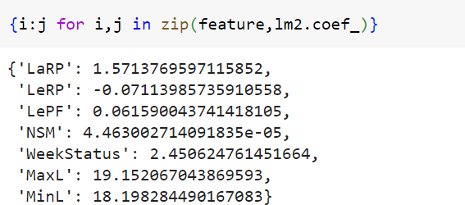

43



# Multi collinearity check:

Multicollinearity is a statistical concept that describes a situation where two or more independent variables in a model are highly correlated with each other, making it difficult to determine the effect of each variable on the dependent variable. This correlation can lead to unreliable and unstable estimates of regression coefficients.

When the dataset contains any multicollinear variable we may not get accurate results we have to remove those attributes. So, we use variance inflation factor to remove those variables from our dataset.

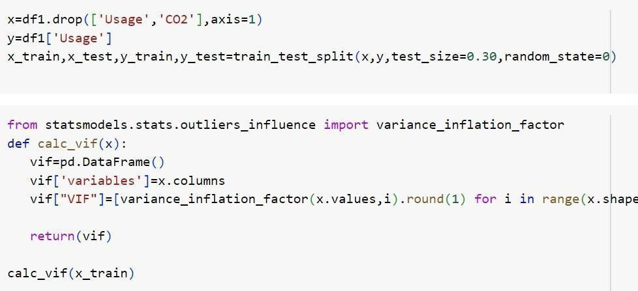

## Here the variables with the highest variance inflation factor (VIF >10) will be removed.

44



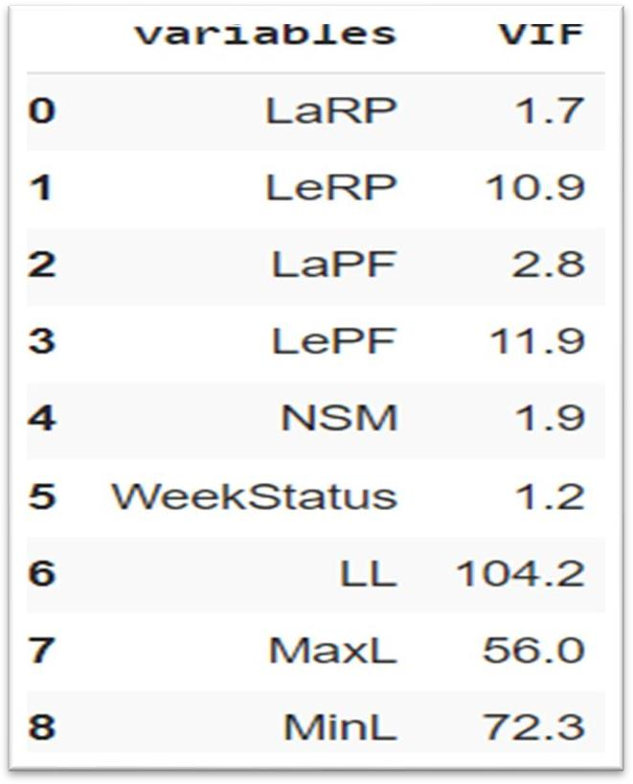

The variable LL was **removed**

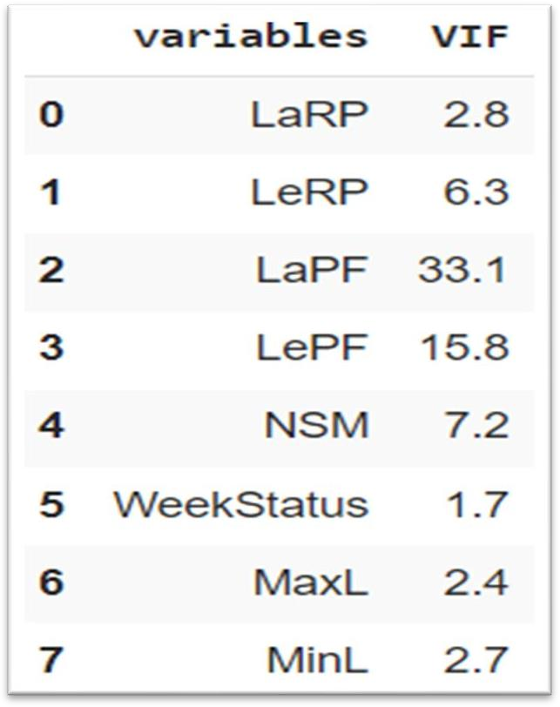

## The variable LaPF was removed

45



# Methodology:

We used different machine learning algorithms for analysis.

Which includes linear regression, decision tree, random forest, K-nearest neighbors, support vector machines, bagging and boosting to predict power

consumption.

# Multiple Linear Regression (MLR):

Multiple linear regression refers to a statistical technique that uses two or more independent variables to predict the outcome

of a dependent variable. The technique enables analysts to determine the variation of the model and the relative contribution of each independent variable in the total variance.

## Assumptions

* + - Level of measurement
    - Sample size
    - Normality
    - Linearity
    - Homoscedasticity
    - Multicollinearity
    - Multi-variate outliers
    - Normality of residuals

## Types of Multiple Linear Regression (MLR):

There are several types of Multiple Linear Regression (MLR), including

* + - Standard Multiple Linear Regression (MLR)
    - Hierarchical Multiple Linear Regression (MLR)
    - Forward Multiple Linear Regression (MLR)
    - Backward Multiple Linear Regression (MLR)
    - Stepwise Multiple Linear Regression (MLR)

46



## Applications

We can use multiple regression to investigate the influence of various factors on health outcomes, such as blood pressure, cholesterol, or diabetes.

For example, you can create a model that predicts blood pressure based on variables such as age, gender, weight, diet, exercise, and medication

**Steps to implement Linear Regression in Python**

1. Step 1: Import the required python packages. ...
2. Step 2: Load the dataset. ...
3. Step 3: Data analysis. ...
4. Step 4: Split the dataset into dependent/independent variables. ...
5. Step 4: Split data into Train/Test sets. ...
6. Step 5: Train the regression model. ...
7. Step 6: Predict the result

# Computation

## Model 1(with all the independent features except CO2):

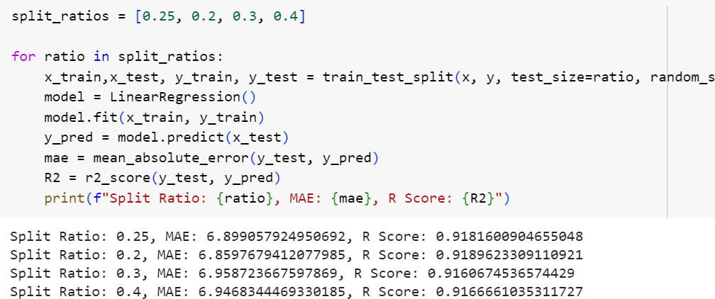

47



## Model 2(without multicollinear variables):

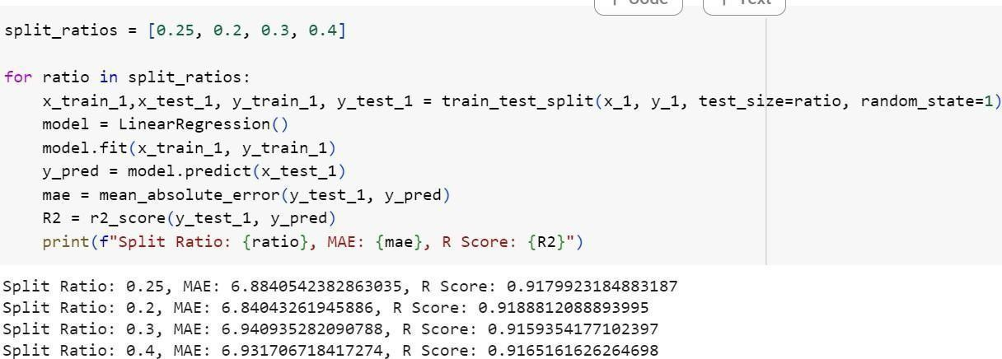

**Model 3(without insignificant variables):**

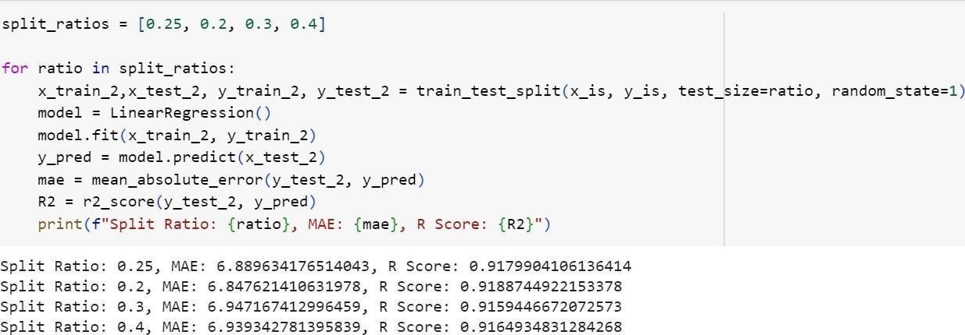

48



## Analysis of a algorithm using R-square and Mean Absolute Error (MAE):

The model with greatest R- square and minimum MAE value is considered to be a best fit.

Here, model 3 with r2 score 0.919 and MAE value 6.86 with splitting ratio 80:20 is considered to be a best fit

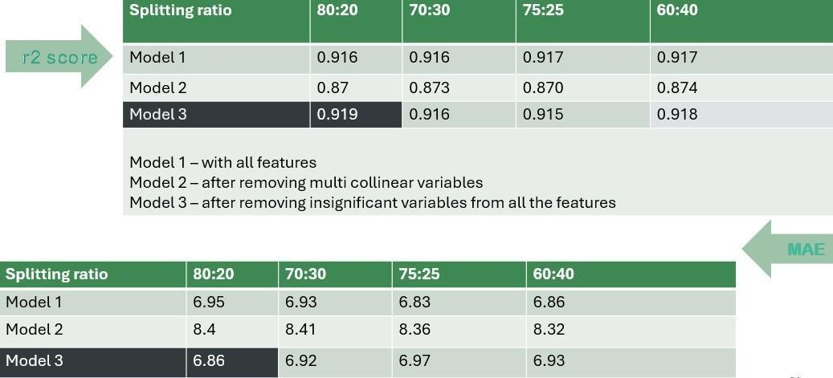

49



# Decision Tree:

Decision tree regression observes features of an object and trains a model in the structure of a tree to predict data in the future to produce meaningful continuous output. Continuous output means that the output/result is not discrete, i.e., it is not represented just by a discrete, known set of numbers or values.

## Advantages

* + - Simple to understand and interpret
    - Able to handle both numerical and [categorical](https://en.wikipedia.org/wiki/Categorical_variable) data
    - Requires little data preparation
    - Uses a [white box](https://en.wikipedia.org/wiki/White_box_(software_engineering)) or open-box[[3]](https://en.wikipedia.org/wiki/Decision_tree_learning#cite_note-tdidt-3) model
    - Possible to validate a model using statistical tests.
    - Performs well with large datasets.

## Disadvantages of Decision Trees

* + - Prone to Overfitting.
    - Unstable to Changes in the Data.
    - Unstable to Noise.
    - Non-Continuous.

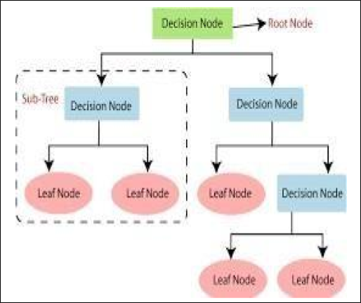

50



## Limitations

* + - Trees can be very non-robust. A small change in the [training data](https://en.wikipedia.org/wiki/Training%2C_test%2C_and_validation_sets) can result in a large change in the tree and consequently the final predictions.
    - Decision-tree learners can create over-complex trees that do not generalize well from the training data. (This is known as [overfitting](https://en.wikipedia.org/wiki/Overfitting).) Mechanisms such as [pruning](https://en.wikipedia.org/wiki/Pruning_(decision_trees)) are necessary to avoid this problem (with the exception of some algorithms such as the Conditional Inference approach, that does not require pruning).
    - The average depth of the tree that is defined by the number of nodes or tests till classification is not guaranteed to be minimal or small under various splitting criteria.
    - For data including categorical variables with different numbers of levels, [information](https://en.wikipedia.org/wiki/Information_gain_in_decision_trees) [gain in decision trees](https://en.wikipedia.org/wiki/Information_gain_in_decision_trees) is biased in favor of attributes with more levels. To counter this problem, instead of choosing the attribute with highest [information gain](https://en.wikipedia.org/wiki/Information_gain), one can choose the attribute with the highest [information gain ratio](https://en.wikipedia.org/wiki/Information_gain_ratio) among the attributes whose information gain is greater than the mean information gain. This biases the decision tree against considering attributes with many distinct values, while not giving an unfair advantage to attributes with very low information gain. Alternatively, the issue of biased predictor selection can be avoided by the Conditional Inference approach, a two-stage approach, or adaptive leave-one-out feature selection.

**Steps to implement decision tree in python:**

* + - Step 1: Import the Necessary Libraries. ...
    - Step 2: Load the Dataset. ...
    - Step 3: Split the Data into Training and Test Sets. ...
    - Step 4: Build the Decision Tree Model. ...
    - Step 5: Make Predictions and Evaluate the Model. ...
    - Step 6: Visualize the Decision Tree

51

# Computation

## Model 1(with all the independent features except CO2):

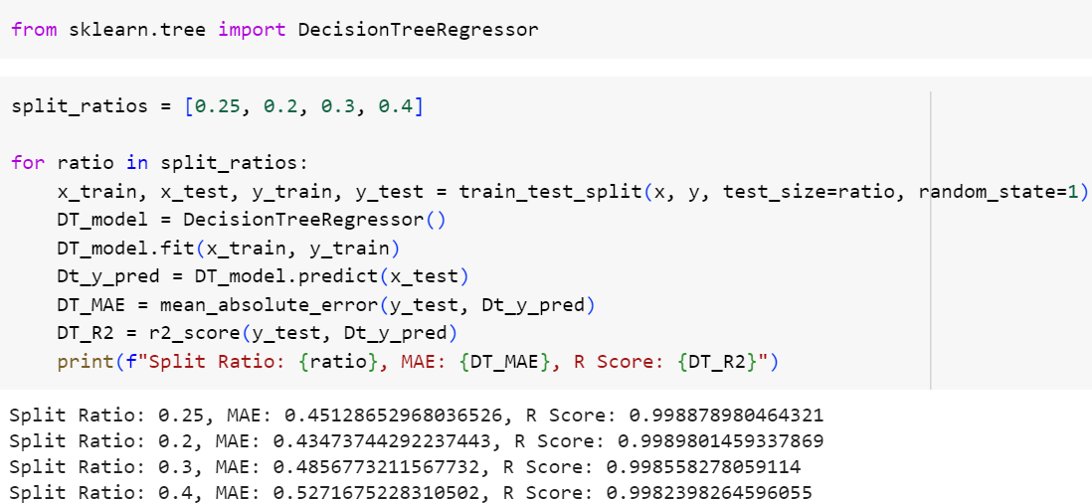

**Model 2(without multicollinear variables):**

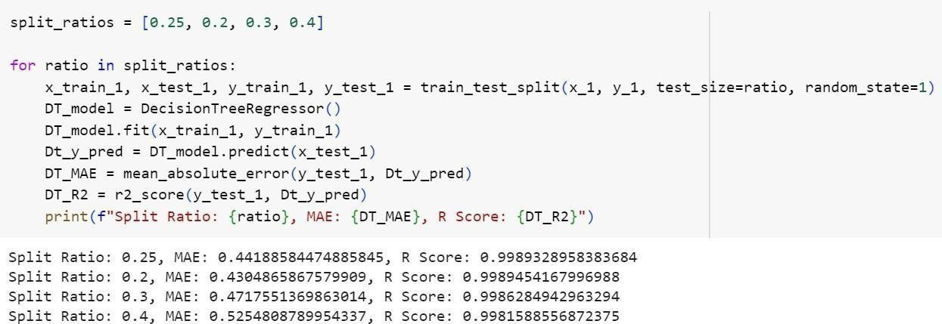

52



## Model 3(without insignificant variables):

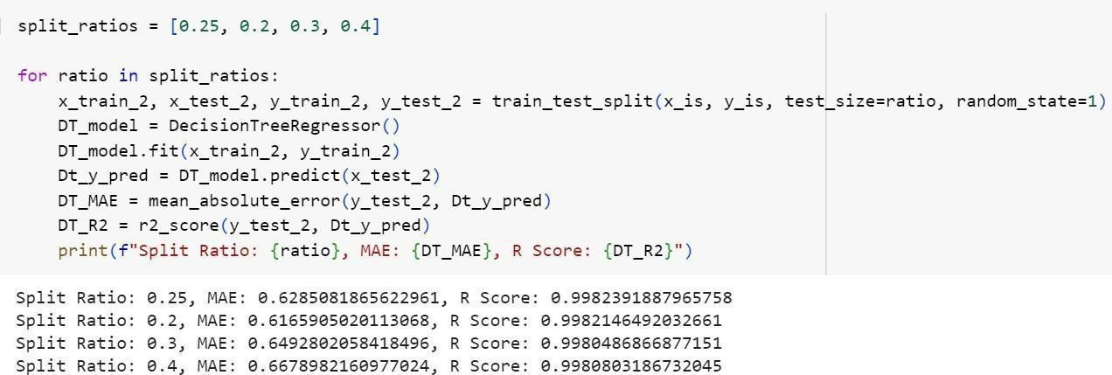

**Analysis of a algorithm using R- square and Mean Absolute Error (MAE):**

Here, model 2 with R- square 0.895 and MAE value 5.78 with splitting ratio 75:25 is considered to be a best fit

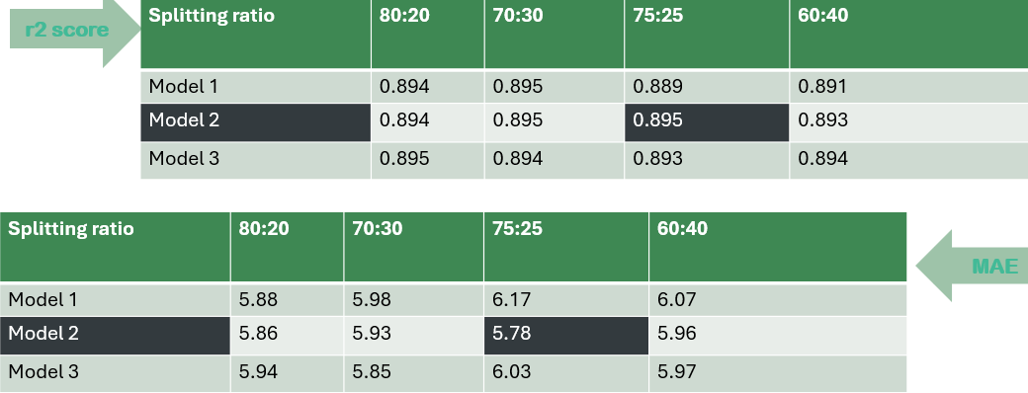

53



# Random Forest:

Random Forest Regression in machine learning is an [ensemble technique](https://www.geeksforgeeks.org/ensemble-methods-in-python/) capable of performing both [regression and classification](https://www.geeksforgeeks.org/regression-classification-supervised-machine-learning/) tasks with the use of multiple decision trees and a technique called Bootstrap and Aggregation, commonly known as [bagging.](https://www.geeksforgeeks.org/bagging-vs-boosting-in-machine-learning/) The basic idea behind this is to combine multiple decision trees in determining the final output rather than relying on individual decision trees.

Random Forest has multiple decision trees as base learning models. We randomly perform row sampling and feature sampling from the dataset forming sample datasets for every model. This part is called Bootstrap.

## Properties

* + - Variable importance
    - Permutation Importance
    - Mean Decrease in Impurity Feature Importance
    - Relationship to nearest neighbors

## Advantages of Random Forest

* + - Random forests are highly accurate and powerful.
    - Random forests are easy to use, interpret and visualize.
    - The training time of a random forest is fast compared to many other techniques.
    - They are resistant to overfitting and can be used to estimate missing data

## Disadvantages of Random Forest

* + - Random forests are prone to overfitting if the data contains a large number of features.
    - Random forests are very slow in making predictions when compared to other algorithms.
    - They are not suitable for real-time applications as they require the entire dataset to be stored in memory.

54



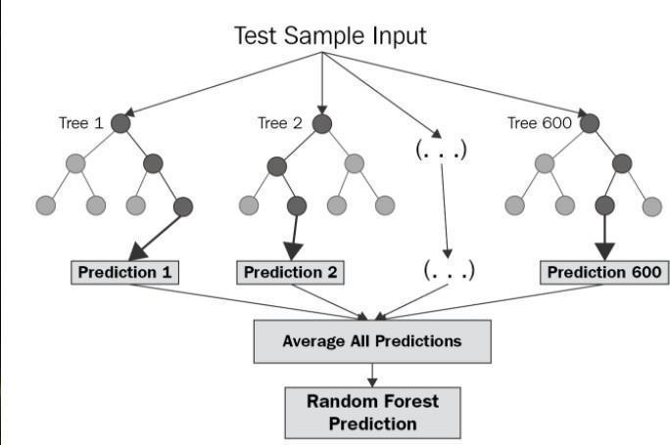

**Step to implement random forest in python:**

1. Step 1: Identify your dependent (y) and independent variables (X) ...
2. Step 2: Split the dataset into the Training set and Test set. ...
3. Step 3: Training the Random Forest Regression model on the whole dataset. ...
4. Step 4: Predicting the Test set results.

55

## Computation

**Model 1(with all the independent features except CO2):**

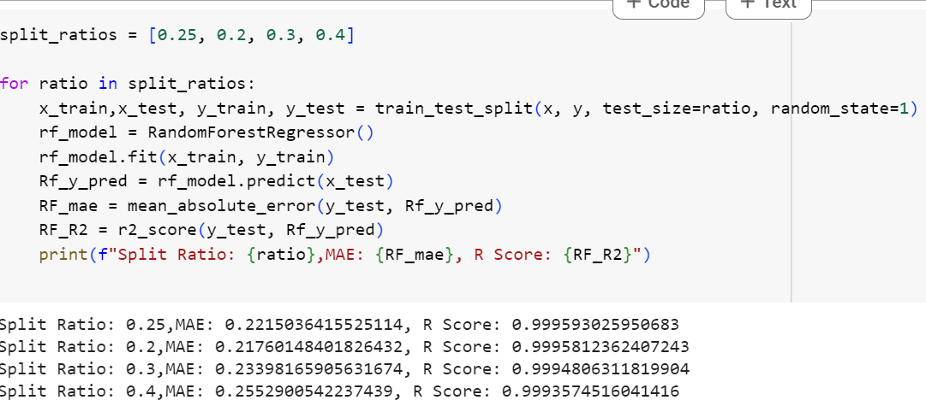

## Model 2(without multicollinear variables):

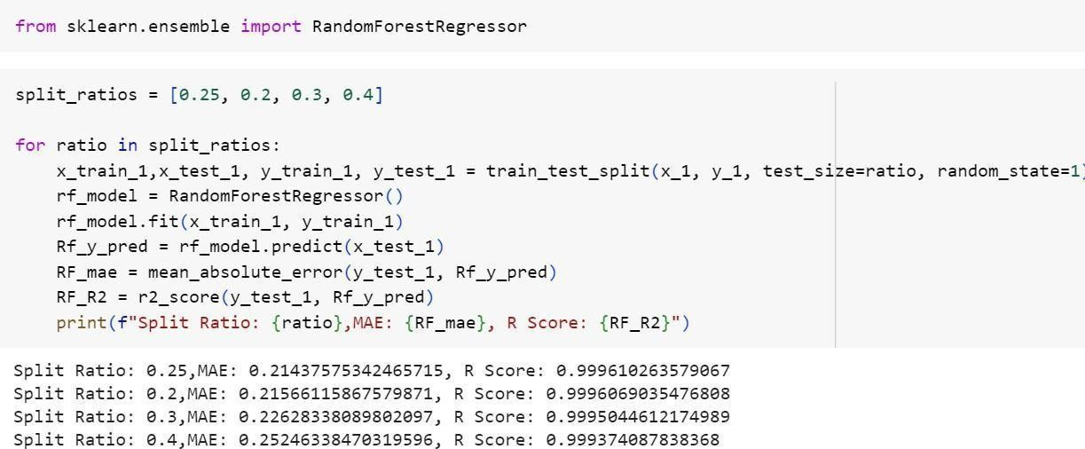

56



## Model 3(without insignificant variables):

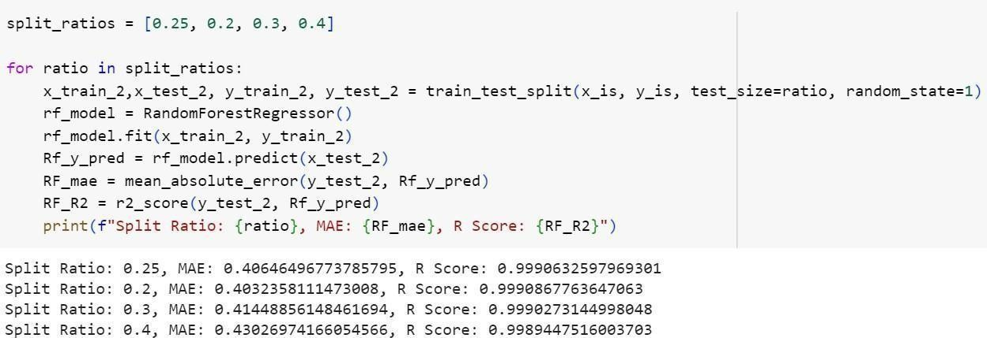

**Analysis of a algorithm using R- square and Mean Absolute Error (MAE):**

Here, model 2 with R- square 0.999 and MAE value 0.19 with splitting ratio 80:20 is considered to be a best fit

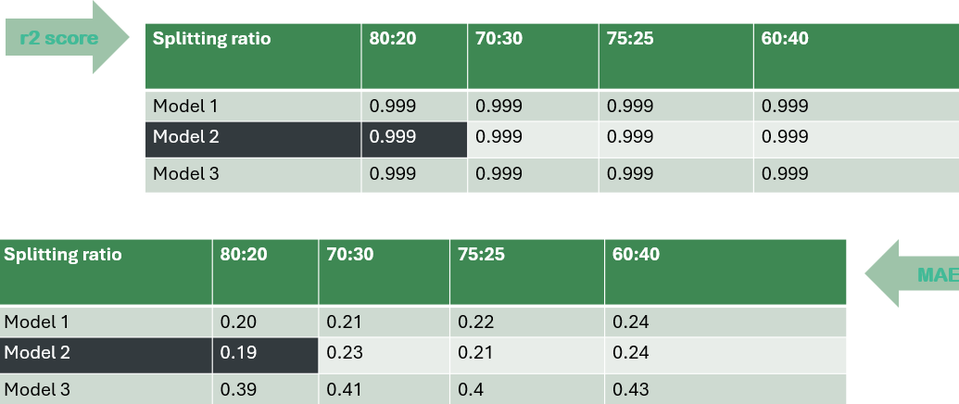

57



# K- Nearest Neighbors:

The *k*-nearest neighbors algorithm (*k*-NN) is a [non-parametric](https://en.wikipedia.org/wiki/Non-parametric_statistics) [supervised learning](https://en.wikipedia.org/wiki/Supervised_learning) method first developed by [Evelyn Fix](https://en.wikipedia.org/wiki/Evelyn_Fix) and [Joseph Hodges](https://en.wikipedia.org/wiki/Joseph_Lawson_Hodges_Jr) in 1951,[[1]](https://en.wikipedia.org/wiki/K-nearest_neighbors_algorithm#cite_note-1) and later expanded by [Thomas](https://en.wikipedia.org/wiki/Thomas_M._Cover) [Cover.](https://en.wikipedia.org/wiki/Thomas_M._Cover)

The input consists of the *k* closest training examples in a [data set.](https://en.wikipedia.org/wiki/Data_set) In *k-NN regression*, the output is the property value for the object. This value is the average of the values of *k* nearest neighbors. If *k* = 1, then the output is simply assigned to the value of that single nearest neighbor.

## Advantages:

* + - Easy to use: KNN is intuitive and simple to implement.
    - Quick calculation time: KNN has a quick calculation time.
    - No training time: KNN doesn't require an explicit training step, so all the work happens during prediction.
    - Evolves with new data: As new data is added to the dataset, the prediction is adjusted without retraining a new model.
    - Versatile: KNN is versatile and can learn non-linear decision boundaries when used for classification and regression.

## Disadvantages:

A disadvantage of the KNN algorithm is that it does not create a generalized separable model. There is no summary equations or trees that can be produced by the training process that can be quickly applied to new records. Instead, KNN simply uses the training data itself to perform prediction.

58



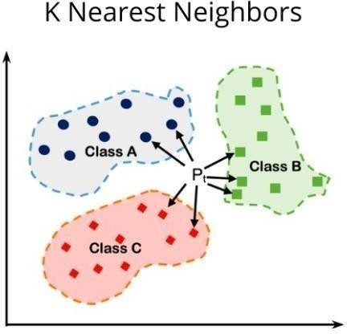

**Steps to implement KNN in python:**

Step-1: Load the data.

Step-2: Initialize the value of k.

Step-3: For getting the predicted class, iterate from 1 to total number of training data points. Calculate the distance between test data and each row of training dataset.

## Computation

**Model 1(with all the independent features except CO2):**

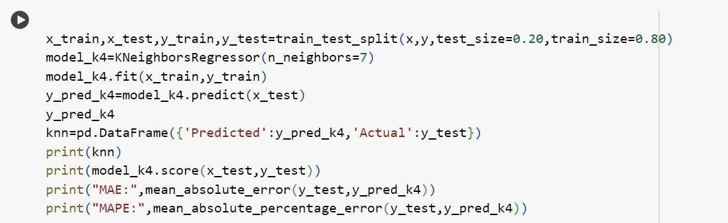

59



## Model 2(without multicollinear variables):

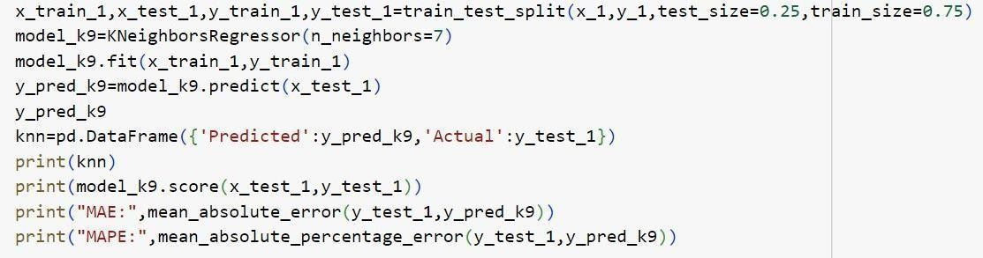

**Model 3(without insignificant variables):**

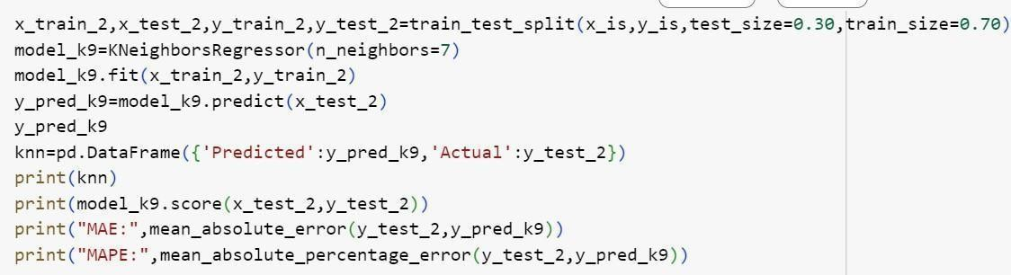

60



## Analysis of a algorithm using R- square and Mean Absolute Error (MAE):

Here, model 3 with R-square 0.998 and MAE value 0.64 with splitting ratio 80:20 is considered to be a best fit.

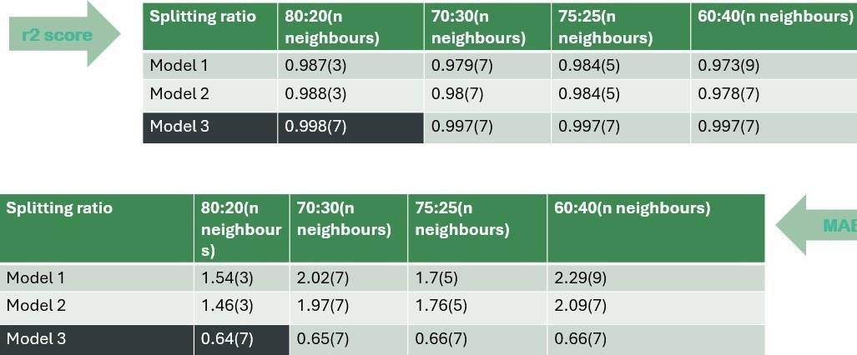

61



# Bagging Regressor:

Bagging, also known as bootstrap aggregation, is the ensemble learning method that is commonly used to reduce variance within a noisy data set. In bagging, a random sample of data in a training set is selected with replacement—meaning that the individual data points can be chosen more than once.

Bagging involves training multiple models independently on random subsets of the data, and aggregating their predictions through voting or averaging.

## Application of the Bagging:

* + - **IT:** Bagging can also improve the precision and accuracy of IT structures, together with network intrusion detection structures.
    - **Environment**: Ensemble techniques, together with Bagging, were carried out inside the area of far-flung sensing. This study indicates how it has been used to map the styles of wetlands inside a coastal landscape
    - **Finance:** Bagging has also been leveraged with deep gaining knowledge of models within the finance enterprise, automating essential tasks, along with fraud detection, credit risk reviews, and option pricing issues.
    - **Healthcare:** used for various bioinformatics issues, including gene and protein selection, to perceive a selected trait of interest. More significantly, this study mainly delves into its use to expect the onset of diabetes based on various threat predictors.
    - **Easier for implementation:** Python libraries, including scikit-examine (sklearn), make it easy to mix the predictions of base beginners or estimators to enhance model performance. Their documentation outlines the available modules you can leverage for your model optimization
    - **Variance reduction:** The Bagging can reduce the variance inside a getting to know set of rules which is especially helpful with excessive-dimensional facts, where missing values can result in better conflict, making it more liable to overfitting and stopping correct generalization to new datasets

62



## Advantages of Bagging

Bagging is beneficial because it reduces variance and helps prevent overfitting by combining predictions from multiple models trained on different subsets of the data. This ensemble approach often improves generalization and robustness, especially for complex models.

## Disadvantages of Bagging

* + - It may result in high bias if it is not modeled properly and thus may result in underfitting.
    - Since we must use multiple models, it becomes computationally expensive and may not be suitable in various use cases.

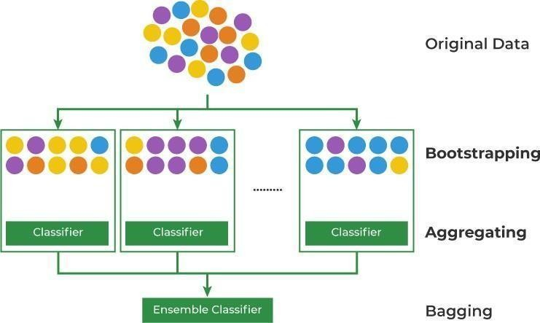

## Steps to implement bagging in python:

Step 1: Multiple subsets are made from the original information set with identical tuples, deciding on observations with replacement.

Step 2: A base model is created on all subsets.

Step 3: Every version is found in parallel with each training set and unbiased.

Step 4: The very last predictions are determined by combining the forecasts from all models.

63

## Computation

**Model 1(with all the independent features except CO2):**

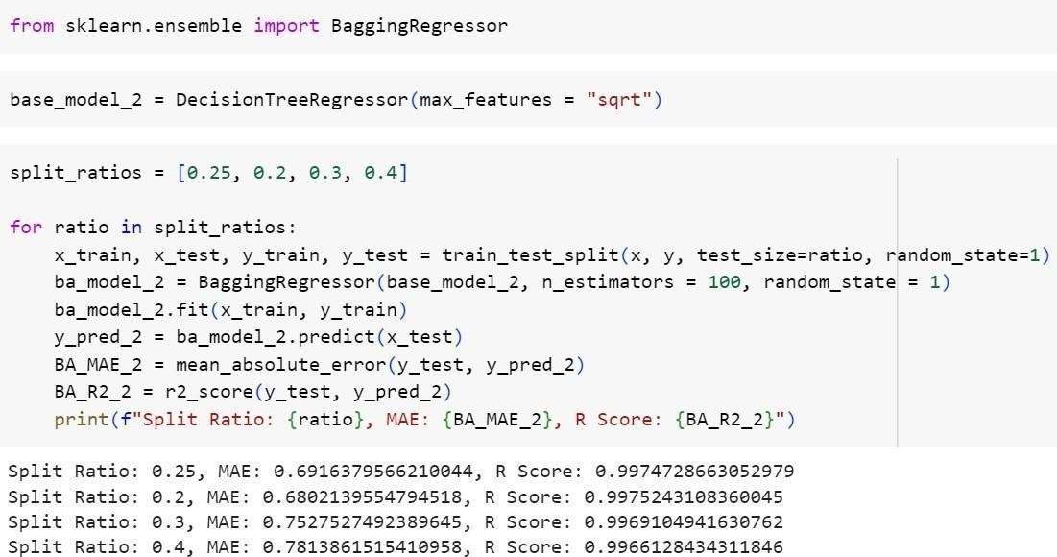

## Model 2(without multicollinear variables):

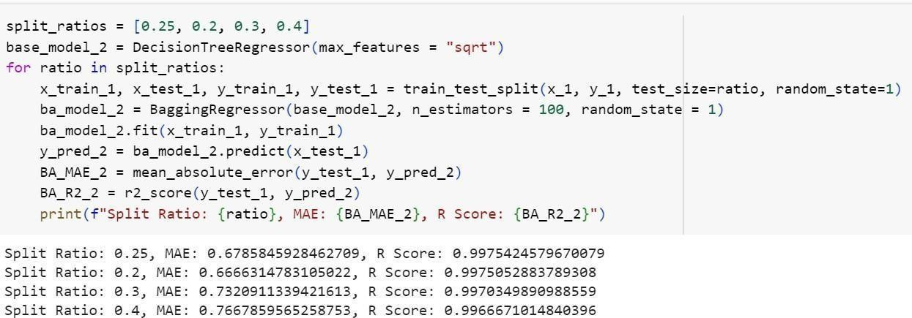

64



## Model 3(without insignificant variables):

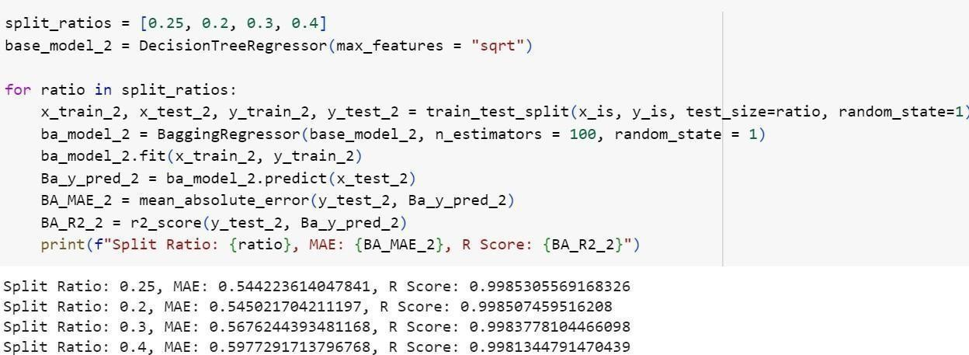

65



## Analysis of a algorithm using R- square and Mean Absolute Error (MAE):

Here, model 2 with R- square 0.997 and MAE value 0.64 with splitting ratio 80:20 is considered to be a best fit.

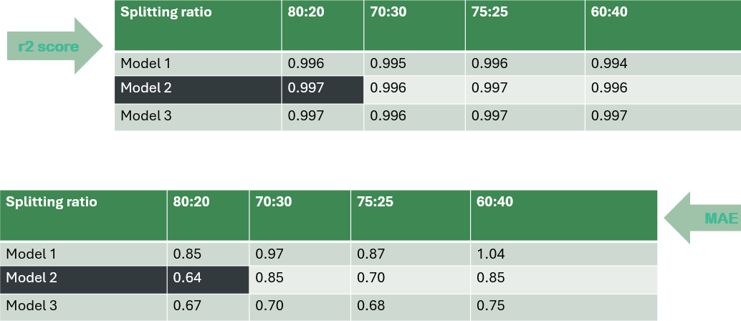

66



# Boosting Regressor:

Boosting is an [ensemble](https://en.wikipedia.org/wiki/Ensemble_learning) [meta-algorithm](https://en.wikipedia.org/wiki/Meta-algorithm) for primarily reducing [bias,](https://en.wikipedia.org/wiki/Bias-variance_tradeoff) variance. While boosting is not algorithmically constrained, most boosting algorithms consist of iteratively learning weak classifiers with respect to a distribution and adding them to a final strong classifier. When they are added, they are weighted in a way that is related to the weak learners' accuracy. After a weak learner is added, the data weights are readjusted, known as "re-[weighting](https://en.wikipedia.org/wiki/Weighting)". Misclassified input data gain a higher weight and examples that are classified correctly lose weight. Thus, future weak learners focus more on the examples that previous weak learners misclassified.

# Uses

Gradient boosting can be used in the field of [learning to rank.](https://en.wikipedia.org/wiki/Learning_to_rank) The commercial web search engines [Yahoo](https://en.wikipedia.org/wiki/Yahoo) and [Yandex](https://en.wikipedia.org/wiki/Yandex) use variants of gradient boosting in their machine-learned ranking engines. Gradient boosting is also utilized in High Energy Physics in data analysis. At the Large Hadron Collider (LHC), variants of gradient boosting Deep Neural Networks (DNN) were successful in reproducing the results of non-machine learning methods of analysis on datasets used to discover the [Higgs boson](https://en.wikipedia.org/wiki/Higgs_boson)[.[16]](https://en.wikipedia.org/wiki/Gradient_boosting#cite_note-16) Gradient boosting decision tree was also applied in earth and geological studies – for example quality evaluation of sandstone reservoir.

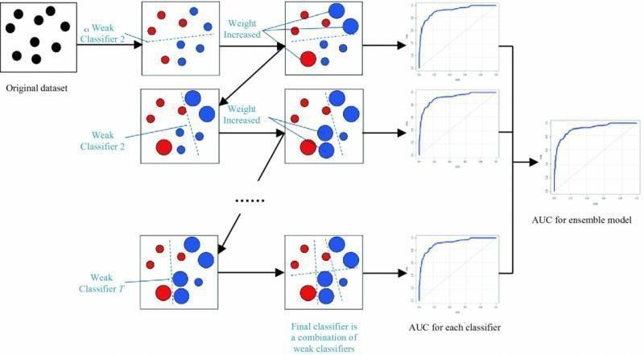

67



## Advantages of Boosting

* + - Significant Improvement in Accuracy: Boosting can significantly enhance the accuracy of weak models by iteratively refining their predictions. ...
    - Effective Handling of Class Imbalance: Boosting addresses class imbalance by assigning higher weights to misclassified instances.

## Disadvantages of boosting:

* + - * It is sensitive to outliers since every classifier is obliged to fix the errors in the predecessors. Thus, the method is too dependent on outliers. Another disadvantage is that the method is almost impossible to scale up.

**Steps to implement gradient boosting in python:**

Step-1: Import the necessary libraries

Step-2: Load the digit dataset and split it into train and test.

Step-3: Instantiate Gradient Boosting regressor and fit the model. Step-4: Predict the test set and compute the accuracy score

68



## Computation

**Model 1(with all the features except CO2):**

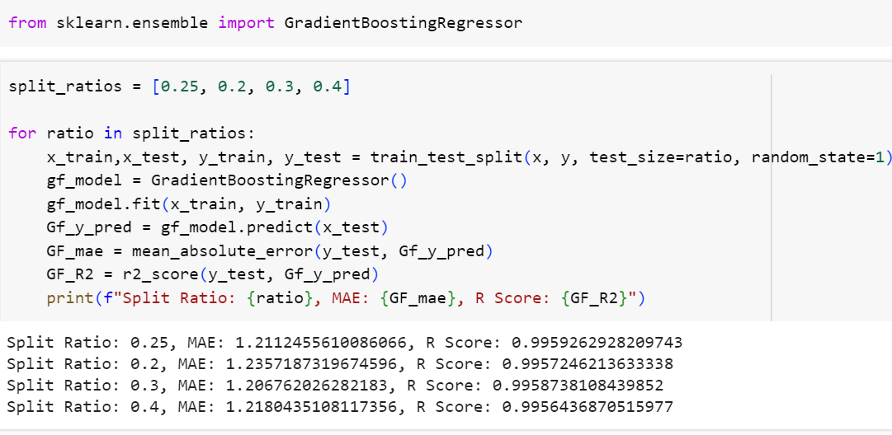

Model 2(without multicollinear variables):

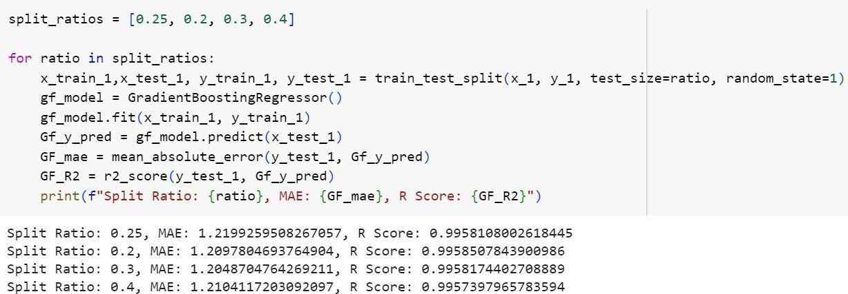

69



## Model 3(without insignificant variable):

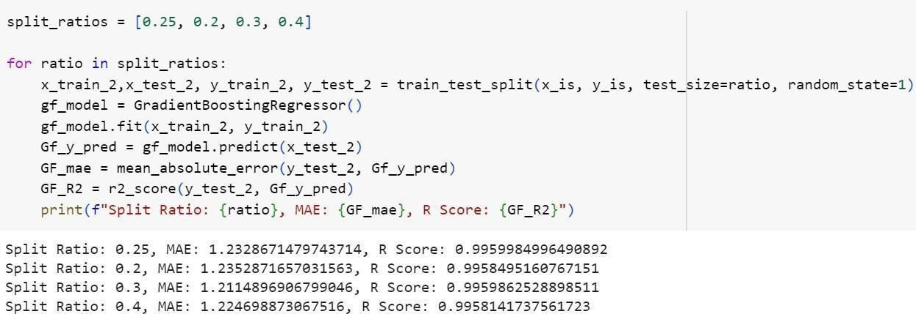

**Analysis of a algorithm using r2 score and Mean Absolute Error (MAE):**

Here, model 2 with r2 score 0.998 and MAE value 1.21 with splitting ratio 70:30 is considered to be a best fit.

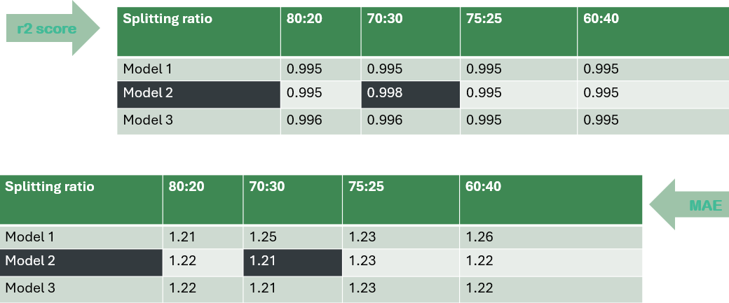

70



# Support Vector Machines:

Support vector regression (SVR) is a type of support vector machine (SVM) that is used for regression tasks. It tries to find a function that best predicts the continuous output value for a given input value.

SVR can use both linear and non-linear kernels. A linear kernel is a simple dot product between two input vectors, while a non-linear kernel is a more complex function that can capture more intricate patterns in the data. The choice of kernel depends on the data’s characteristics and the task’s complexity.

## Applications

SVMs can be used to solve various real-world problems:

* + - SVMs are helpful in [text and hypertext categorization](https://en.wikipedia.org/wiki/Text_categorization), as their application can significantly reduce the need for labeled training instances in both the standard inductive and [transductive](https://en.wikipedia.org/wiki/Transduction_(machine_learning)) settings. Some methods for [shallow semantic parsing](https://en.wikipedia.org/wiki/Shallow_semantic_parsing) are based on support vector machines.
    - [Classification of images](https://en.wikipedia.org/wiki/Image_classification) can also be performed using SVMs. Experimental results show that SVMs achieve significantly higher search accuracy than traditional query refinement schemes after just three to four rounds of relevance feedback. This is also true for [image segmentation](https://en.wikipedia.org/wiki/Image_segmentation) systems, including those using a modified version SVM that uses the privileged approach as suggested by Vapnik.
    - Classification of satellite data like [SAR](https://en.wikipedia.org/wiki/Synthetic-aperture_radar) data using supervised SVM. Hand-written characters can be [recognized](https://en.wikipedia.org/wiki/Handwriting_recognition) using SVM.
    - The SVM algorithm has been widely applied in the biological and other sciences. They have been used to classify proteins with up to 90% of the compounds classified correctly. [Permutation tests](https://en.wikipedia.org/wiki/Permutation_test) based on SVM weights have been suggested as a mechanism for interpretation of SVM models. Support vector machine weights have also been used to interpret SVM models in the past. Posthoc interpretation of support vector machine models in order to identify features used by the model to make predictions is a relatively new area of research with special significance in the biological sciences.

71



## Advantages

Support Vector Machine (SVM) has many advantages, including:

* + - Linear data: SVM works well when data is linear.
    - High dimensions: SVM is more effective in high dimensions, even when the number of dimensions is greater than the number of samples.
    - Kernel trick: SVM can solve complex problems using the kernel trick

## Disadvantages

Long training time for large datasets. Difficult to understand and interpret the final model, variable weights and individual impact. Since the final model is not so easy to see, we can not do small calibrations to the model hence its tough to incorporate our business logic.

For support vector regressor as we did not get the output for the original data we have

**standardized the data** and then performed the SVM task.

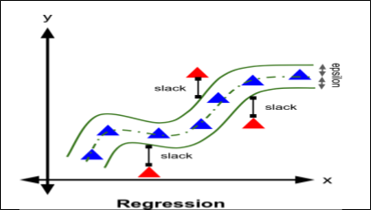

72



## Standardizing the data:

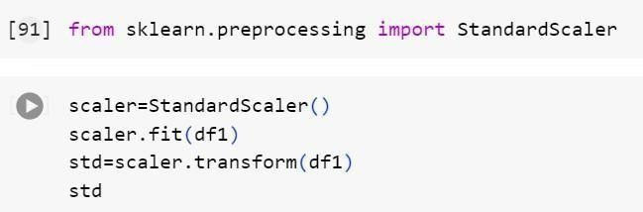

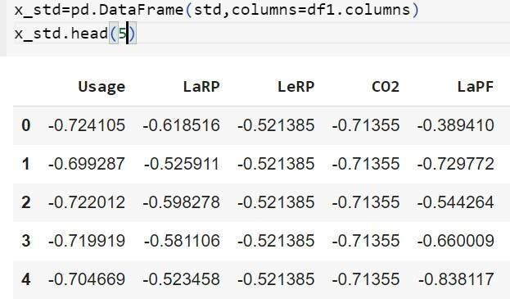

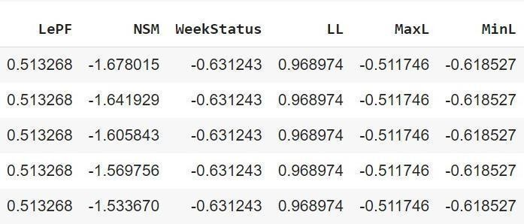

73



## Support vector regressor:

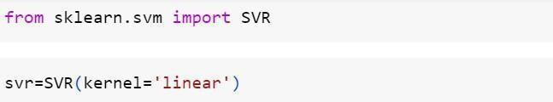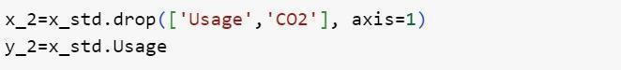

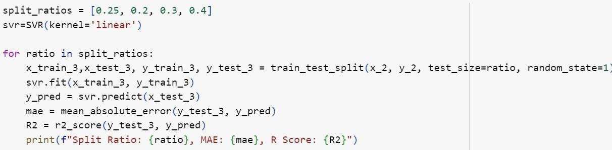

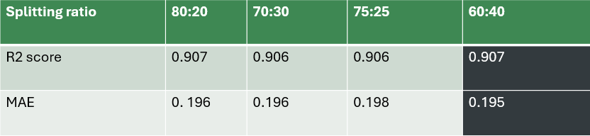

74



1. **Comparison of Algorithms:**

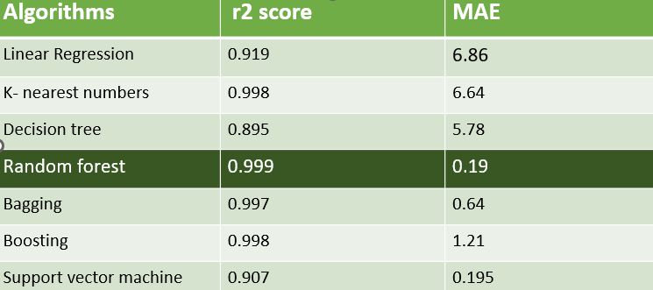

1. **Conclusion:**
   * One of the most important issues for energy management and optimization in the steel industry is a precise long-term prediction of energy consumption. The data analysis shows thought-provoking outcomes in the exploratory analysis.
   * The purpose of this research is to determine the best performing machine learning techniques to predict the energy consumption in the steel industry.
   * The findings indicate that the RF model improves MAE and r2 score of predictions in consideration to other regression models considered in this research.

75

1. **References:**

**Dataset**

[**https://archive.ics.uci.edu/dataset/851/steel+industry+energy+consumption**](https://archive.ics.uci.edu/dataset/851/steel%2Bindustry%2Benergy%2Bconsumption)

**Steel industry**

<https://en.wikipedia.org/wiki/Steel>

**Steel industry in South Korea**

<https://www.kosa.or.kr/sub/eng/introduction/sub02.jsp>

**Literature review**

* [https://r.search.yahoo.com/_ylt=AwrjbI0GPbxmJqcEHn1XNyoA;_ylu=Y29sbwNnc](https://r.search.yahoo.com/_ylt%3DAwrjbI0GPbxmJqcEHn1XNyoA%3B_ylu%3DY29sbwNncTEEcG9zAzQEdnRpZAMEc2VjA3Ny/RV%3D2/RE%3D1724822023/RO%3D10/RU%3Dhttps%3a%2f%2fwww.pubs2.ascee.org%2findex.php%2fIJRCS%2farticle%2fdownload%2f1234%2fpdf/RK%3D2/RS%3DMv2_uR6XohqslVWnCKoUklLeGPw-) [T](https://r.search.yahoo.com/_ylt%3DAwrjbI0GPbxmJqcEHn1XNyoA%3B_ylu%3DY29sbwNncTEEcG9zAzQEdnRpZAMEc2VjA3Ny/RV%3D2/RE%3D1724822023/RO%3D10/RU%3Dhttps%3a%2f%2fwww.pubs2.ascee.org%2findex.php%2fIJRCS%2farticle%2fdownload%2f1234%2fpdf/RK%3D2/RS%3DMv2_uR6XohqslVWnCKoUklLeGPw-) [EEcG9zAzQEdnRpZAMEc2VjA3Ny/RV=2/RE=1724822023/RO=10/RU=https%3a](https://r.search.yahoo.com/_ylt%3DAwrjbI0GPbxmJqcEHn1XNyoA%3B_ylu%3DY29sbwNncTEEcG9zAzQEdnRpZAMEc2VjA3Ny/RV%3D2/RE%3D1724822023/RO%3D10/RU%3Dhttps%3a%2f%2fwww.pubs2.ascee.org%2findex.php%2fIJRCS%2farticle%2fdownload%2f1234%2fpdf/RK%3D2/RS%3DMv2_uR6XohqslVWnCKoUklLeGPw-)

[%2f%2fwww.pubs2.ascee.org%2findex.php%2fIJRCS%2farticle%2fdownload%2f1](https://r.search.yahoo.com/_ylt%3DAwrjbI0GPbxmJqcEHn1XNyoA%3B_ylu%3DY29sbwNncTEEcG9zAzQEdnRpZAMEc2VjA3Ny/RV%3D2/RE%3D1724822023/RO%3D10/RU%3Dhttps%3a%2f%2fwww.pubs2.ascee.org%2findex.php%2fIJRCS%2farticle%2fdownload%2f1234%2fpdf/RK%3D2/RS%3DMv2_uR6XohqslVWnCKoUklLeGPw-) [2](https://r.search.yahoo.com/_ylt%3DAwrjbI0GPbxmJqcEHn1XNyoA%3B_ylu%3DY29sbwNncTEEcG9zAzQEdnRpZAMEc2VjA3Ny/RV%3D2/RE%3D1724822023/RO%3D10/RU%3Dhttps%3a%2f%2fwww.pubs2.ascee.org%2findex.php%2fIJRCS%2farticle%2fdownload%2f1234%2fpdf/RK%3D2/RS%3DMv2_uR6XohqslVWnCKoUklLeGPw-) [34%2fpdf/RK=2/RS=Mv2_uR6XohqslVWnCKoUklLeGPw-](https://r.search.yahoo.com/_ylt%3DAwrjbI0GPbxmJqcEHn1XNyoA%3B_ylu%3DY29sbwNncTEEcG9zAzQEdnRpZAMEc2VjA3Ny/RV%3D2/RE%3D1724822023/RO%3D10/RU%3Dhttps%3a%2f%2fwww.pubs2.ascee.org%2findex.php%2fIJRCS%2farticle%2fdownload%2f1234%2fpdf/RK%3D2/RS%3DMv2_uR6XohqslVWnCKoUklLeGPw-)

* [https://r.search.yahoo.com/_ylt=AwrjbI0GPbxmJqcEG31XNyoA;_ylu=Y29sbwNnc](https://r.search.yahoo.com/_ylt%3DAwrjbI0GPbxmJqcEG31XNyoA%3B_ylu%3DY29sbwNncTEEcG9zAzEEdnRpZAMEc2VjA3Ny/RV%3D2/RE%3D1724822023/RO%3D10/RU%3Dhttps%3a%2f%2fkoreascience.kr%2farticle%2fCFKO201924664107981.pdf/RK%3D2/RS%3DqFTz.64dMqygj1jNNmzGM8egfRw-) [T](https://r.search.yahoo.com/_ylt%3DAwrjbI0GPbxmJqcEG31XNyoA%3B_ylu%3DY29sbwNncTEEcG9zAzEEdnRpZAMEc2VjA3Ny/RV%3D2/RE%3D1724822023/RO%3D10/RU%3Dhttps%3a%2f%2fkoreascience.kr%2farticle%2fCFKO201924664107981.pdf/RK%3D2/RS%3DqFTz.64dMqygj1jNNmzGM8egfRw-) [EEcG9zAzEEdnRpZAMEc2VjA3Ny/RV=2/RE=1724822023/RO=10/RU=https%3a](https://r.search.yahoo.com/_ylt%3DAwrjbI0GPbxmJqcEG31XNyoA%3B_ylu%3DY29sbwNncTEEcG9zAzEEdnRpZAMEc2VjA3Ny/RV%3D2/RE%3D1724822023/RO%3D10/RU%3Dhttps%3a%2f%2fkoreascience.kr%2farticle%2fCFKO201924664107981.pdf/RK%3D2/RS%3DqFTz.64dMqygj1jNNmzGM8egfRw-)

[%2f%2fkoreascience.kr%2farticle%2fCFKO201924664107981.pdf/RK=2/RS=qFT](https://r.search.yahoo.com/_ylt%3DAwrjbI0GPbxmJqcEG31XNyoA%3B_ylu%3DY29sbwNncTEEcG9zAzEEdnRpZAMEc2VjA3Ny/RV%3D2/RE%3D1724822023/RO%3D10/RU%3Dhttps%3a%2f%2fkoreascience.kr%2farticle%2fCFKO201924664107981.pdf/RK%3D2/RS%3DqFTz.64dMqygj1jNNmzGM8egfRw-) [z](https://r.search.yahoo.com/_ylt%3DAwrjbI0GPbxmJqcEG31XNyoA%3B_ylu%3DY29sbwNncTEEcG9zAzEEdnRpZAMEc2VjA3Ny/RV%3D2/RE%3D1724822023/RO%3D10/RU%3Dhttps%3a%2f%2fkoreascience.kr%2farticle%2fCFKO201924664107981.pdf/RK%3D2/RS%3DqFTz.64dMqygj1jNNmzGM8egfRw-). [64dMqygj1jNNmzGM8egfRw-](https://r.search.yahoo.com/_ylt%3DAwrjbI0GPbxmJqcEG31XNyoA%3B_ylu%3DY29sbwNncTEEcG9zAzEEdnRpZAMEc2VjA3Ny/RV%3D2/RE%3D1724822023/RO%3D10/RU%3Dhttps%3a%2f%2fkoreascience.kr%2farticle%2fCFKO201924664107981.pdf/RK%3D2/RS%3DqFTz.64dMqygj1jNNmzGM8egfRw-)

* + <https://www.sciencedirect.com/science/article/pii/S030626192030458X>

76

**Machine learning algorithms**

* + - [https://www.geeksforgeeks.org/support-vector-regression-svr-using-linear-and-non](https://www.geeksforgeeks.org/support-vector-regression-svr-using-linear-and-non-linear-kernels-in-scikit-learn/)

[- linear-kernels-in-scikit-learn/](https://www.geeksforgeeks.org/support-vector-regression-svr-using-linear-and-non-linear-kernels-in-scikit-learn/)

* + - <https://en.wikipedia.org/wiki/Boosting_(machine_learning)>
    - <https://www.geeksforgeeks.org/random-forest-regression-in-python/>
    - [https://en.wikipedia.org/wiki/K-](https://en.wikipedia.org/wiki/K-nearest_neighbors_algorithm#%3A~%3Atext%3DIn%20k%2DNN%20regression%2C%20the%20k%2DNN%20algorithm%20is%2Cthe%20inverse%20of%20their%20distance) [nearest_neighbors_algorithm#:~:text=In%20k%2DNN%20regression%2C%20the%](https://en.wikipedia.org/wiki/K-nearest_neighbors_algorithm#%3A~%3Atext%3DIn%20k%2DNN%20regression%2C%20the%20k%2DNN%20algorithm%20is%2Cthe%20inverse%20of%20their%20distance) [2 0k%2DNN%20algorithm%20is,the%20inverse%20of%20their%20distance](https://en.wikipedia.org/wiki/K-nearest_neighbors_algorithm#%3A~%3Atext%3DIn%20k%2DNN%20regression%2C%20the%20k%2DNN%20algorithm%20is%2Cthe%20inverse%20of%20their%20distance).
    - [https://www.ibm.com/topics/bagging#:~:text=IBM-](https://www.ibm.com/topics/bagging#%3A~%3Atext%3DIBM-%2CWhat%20is%20bagging%3F%2Cbe%20chosen%20more%20than%20once)

[,What%20is%20bagging%3F,be%20chosen%20more%20than%20once.](https://www.ibm.com/topics/bagging#%3A~%3Atext%3DIBM-%2CWhat%20is%20bagging%3F%2Cbe%20chosen%20more%20than%20once)

* + - <https://en.wikipedia.org/wiki/Decision_tree_learning>
    - <https://www.investopedia.com/terms/m/mlr.asp>

77



78



79



80